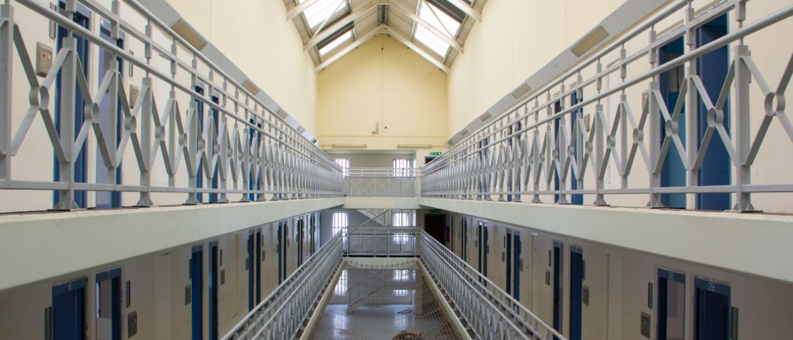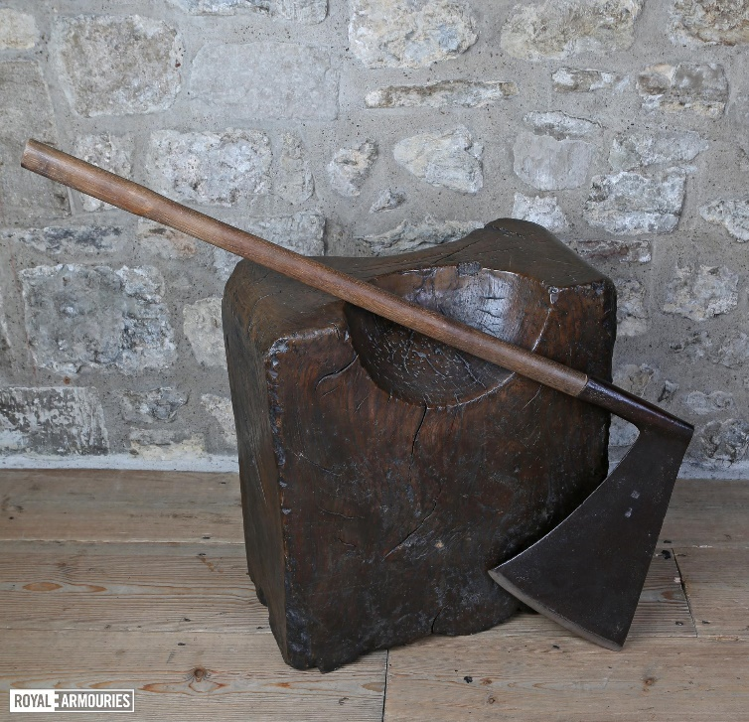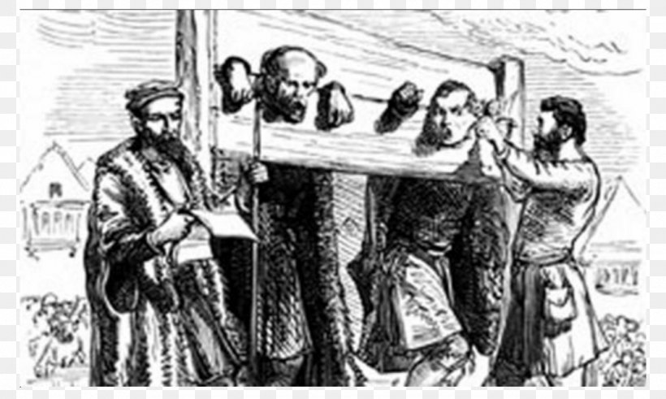

**Crime and punishment Vocabulary**

Crime

Punishment

Deterrence

Protection

Retribution

Reformation

Justice

Prison

Corporal Punishment

Capital Punishment

Community Service

Forgiveness

A modern prison cell block

An executioner’s block and axe

Two men in stocks

How has crime and punishment changed through the ages?

**A brief history of Crime and Punishment**

**During the Romans era, there was…**

A very detailed legal system

Laws to cover every possible crime

Courts and juries

No police – you had to catch the criminal yourself and take them to court

Punishments that depended on your rank

Crucifixion as a punishment.

**During the Anglo Saxon and Viking era, there was…**

Instead of punishment, criminals had to pay the injured party compensation known as wergild.

No police – villages were divided into 10 households called tithings who made sure that wrongdoers were brought to justice.

The death penalty for the most serious of crimes

Trial by Ordeal – subjecting the criminal to a painful death and if God performed a miracle they were innocent

Trial by Water – The criminal was dunked in water and if drowned they were guilty!

Trail by Combat – The criminal would have to fight another man and the winner was innocent

**During the Middle Ages, there was…**

Many women who were accused of witchcraft and burned at the stake

Smugglers became more common as did Poachers.

Highwaymen attacking coaches

Punishments that were very harsh. In 1688 only 50 crimes earned the death penalty, by 1800 it was 200! This system of law became known as the ‘Bloody Code’.

Transportation to America as a punishment

**During the Victorian Period there was…**

Theft, which was still the most common crime

Less smuggling and highwaymen.

More political crimes such as striking and rioting

Introduction of the police force by Sir Robert Peel

Public hangings which continued until 1868

Transportation to Australia instead of America

Prisons were developed as an answer to the end of transportation.

90 prisons were built between 1840 – 1877

Workhouses were introduced

**Anglo Saxon Key Vocabulary**

Saxons

Mead

Rune

Wattle-and-daub

Thatch

Farmer-warrior

Sutton Hoo

Lindisfarne

Monk

Illumination

Manuscript

Christianity

Alfred the Great

**Viking Key Vocabulary**

Longboat

Longhouse

Chieftain

Berserker

Danegeld

Feast

Raid

Trade

Yggdrasil

Runes

Farmer-warrior

Pagan

Danelaw

Asgard

Figurehead

Chainmail

Valhalla