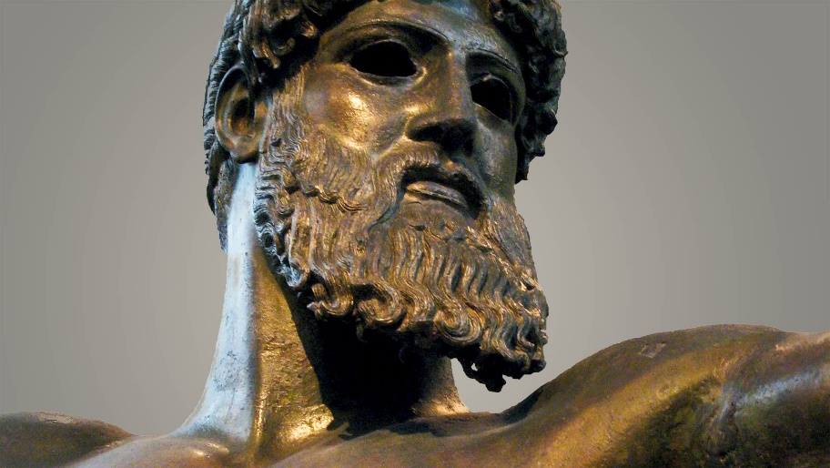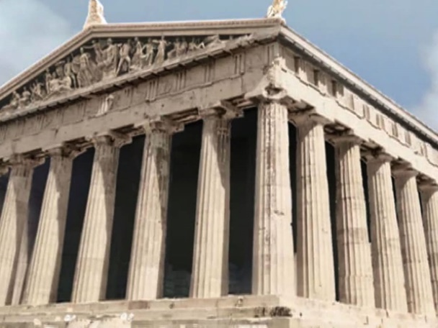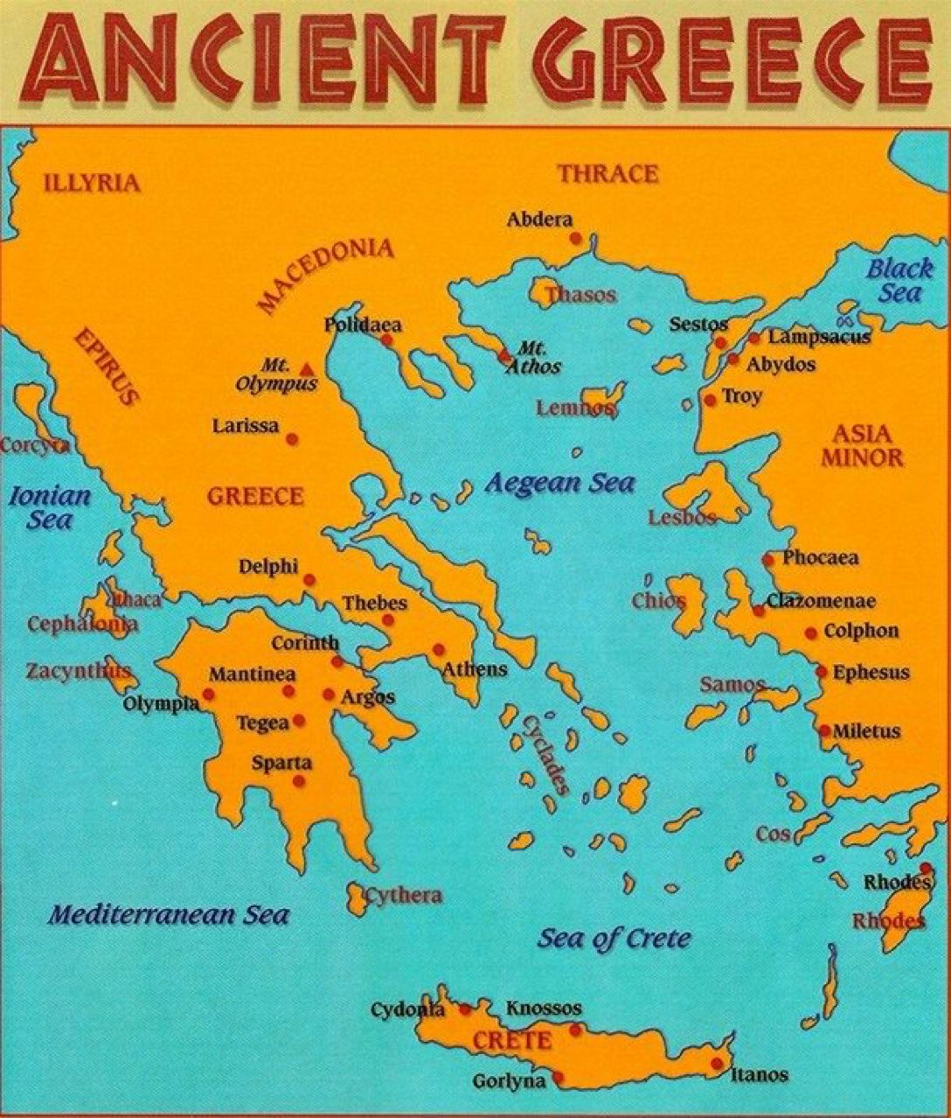

Ancient Greek Sculpture

**Ancient Greek Key Vocabulary**

Democracy

Acropolis

City-state

Parthenon

Marathon

Olympics

Citizen

Philosopher

Alphabet

Tragedy

Agora

Hellenistic

Phalanx

Aristocrat

Mythology

Column

Hoplite

Peninsula

Oracle

Terraced

**Ancient Greek Timeline**

* **700s B.C.E.** – The rise of city-states like Sparta and Athens became the main influences of the area.
* **776 B.C.E.** – The first Olympic Games were played to honor the Greek god Zeus in Olympia.
* **750 B.C.E.** – Two epic poems were written by Homer. The Iliad and Odyssey are considered the most famous items of Greek literature during this time.
* **621 B.C.E.** – Athens introduced Draconian Laws which were created by Draco, a lawyer. Many of the laws were punishable by death.
* **600 B.C.E.** – Coins were struck to be used for currency in Ancient Greece.
* **570 B.C.E.** – Philosopher, scientist, and mathematician named Pythagoras was born. He developed the Pythagorean Theory which is the basis for geometry.
* **508 B.C.E.** – A new government system called Democracy along with a constitution is introduced.

**470 to 469 B.C.E.** – Socrates one of the founders of Western Philosophy is born.

* **468 B.C.E.** – Outdoor amphitheaters were constructed and theater became the number one form of entertainment. Sophocles writes many plays during this time.
* **432 B.C.E.** – The Parthenon was finished on top of the Acropolis. Also known as the Temple to Athena it is the most important building of Ancient Greece that still stands.
* **399 B.C.E.** – Socrates is sentenced to death for corrupting the youth of Athens through his philosophical teachings.
* **386 B.C.E.** – The first institute of higher learning named the Academy was opened by Plato. Plato was star pupil of Socrates.
* **384 B.C.E.** – Aristotle is born. He was tutored in later years by Plato at the Academy.
* **332 B.C.E.** – Alexander the Great defeats Egypt and constructs a new capital city in Egypt named Alexandria. He would continue to grow his empire finally conquering India.

**323 B.C.E.** – Alexander the Great dies. The Ancient Romans begin to secure power and Ancient Greece society is diminished.

* **300 B.C.E.** – Famous Greek mathematician, Euclid, writes *Elements* which continues to influence mathematics today.
* **146 B.C.E.** – Ancient Greece succumbs to the Ancient Romans and becomes part of the Roman Empire.

What did the Ancient Greeks do for us?

Ancient Greek Architecture

A Map of Greece and the surrounding seas

The Sphinx