Autumn Term, Year 6, PE Knowledge Organiser
Badminton
Subject specific  Vocabulary |  | Images/Diagrams/Maps | Important Knowledge
Abide | Act in accordance | 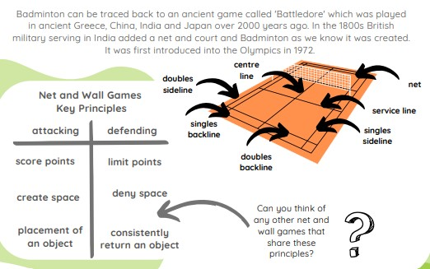 | Shot  Use a variety of shots to move you opponent around court  Serving  Begin to apply tactics when serving e.g. aiming to serve short on the first point and then long on the second point  Rallying  Use different shots and consider placement depending on if the rally is co-operative or competitive  Footwork  Using appropriate footwork will help you to react quickly and give you time to prepare to play a shot
Dominant | Preferred side
Footwork | Patterns used to move around the court
Overhead | A shot played when the shuttle is above head height
Placement | Intentionally hitting the shuttle to a specific place on court
Rally | When point is played back and forth
Rally | When point is played back and forth | Writing/Provision/  Enrichment opportunities
Return | Hitting the shuttlecock back | Writing/Provision/  Enrichment opportunities
Return | Hitting the shuttlecock back | Children will have access to the following equipment at playtimes and lunchtimes in order to apply the skills they have learned in their Pe lessons.  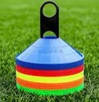      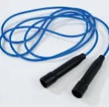  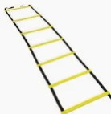
Serve | Used to start a game
Tactic | A plan that helps you to attack or defend
Underarm | A shot played when the shuttle is low

Autumn Term, Year 6, PE Knowledge Organiser
Handball
Subject specific  Vocabulary |  | Images/Diagrams/Maps | Important Knowledge
Angle | Formed when two lines come together at a shared point | 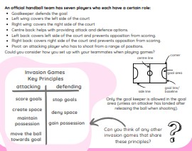 | Sending and receiving  Making quick decision about when, how and who to pass to will help you to maintain possession  Dribbling  Choosing the appropriate skill for the situation under pressure will help you maintain possession  Space  Transitioning quickly between attack and defence will help your team to maintain or gain possession
Consistently | Every time
Dictate | To give order
Maintain | To keep
Possession | To have
React | To respond quickly
React | To respond quickly | Writing/Provision/  Enrichment opportunities
Tactics | A plan that helps you attack or defend | Writing/Provision/  Enrichment opportunities
Tactics | A plan that helps you attack or defend | Children will have access to the following equipment at playtimes and lunchtimes in order to apply the skills they have learned in their Pe lessons.
Transition | Moving from attack to defence or defence to attack

