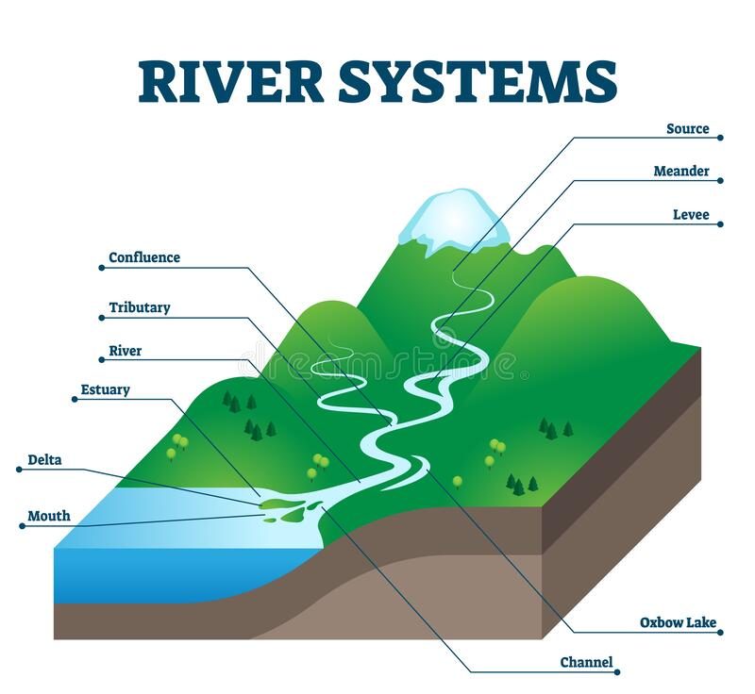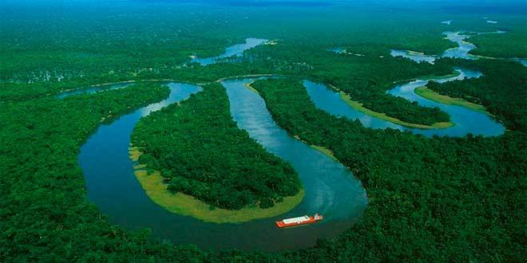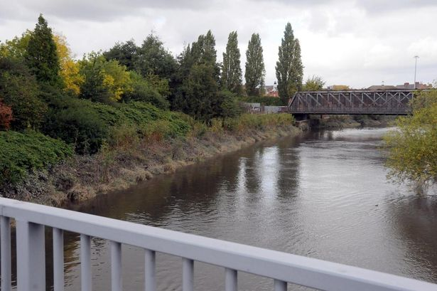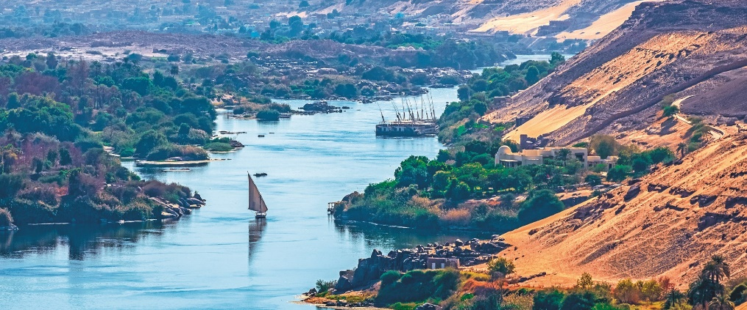

**Key Vocabulary**

bank

basin

bed

current

confluence

delta

downstream erosion

floodplain

fresh water

meander.

**Key Vocabulary**

mouth

salt water

silt

source

stream

tidal river

tributary

upstream

watershed

The Amazon river

Part of the Mersey in Warrington

The Nile

Do all rivers flow to the sea?