Autumn Term, Year 4, PE Knowledge Organiser
Swimming
Subject specific  Vocabulary |  | Images/Diagrams/Maps | Important Knowledge
Backstroke | A swimming style performed on the back | 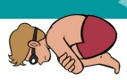 | Strokes  Keeping your legs together for crawl helps you to stay straight in the water  Breathing  Breathing out with a slow consistent breath enables you to swim with good technique  Water Safety  If you fall in the water float
Breaststroke | A swimming style performed on the front
Front crawl | A stroke used in swimming
Glide | Move across the water with a smooth continuous movement
H.E.L.P position | Heat Escape Lessening Posture a position for floating in cold water when wearing a life jacket and awaiting rescue
Handstand | An inverted balance in which weight is held on hands
Handstand | An inverted balance in which weight is held on hands | Writing/Provision/  Enrichment opportunities
Rotation | The circular movement of an object around central point | Writing/Provision/  Enrichment opportunities
Rotation | The circular movement of an object around central point | Water Safety work during Sports Week
Sculling | Quick movements of the hands to keep the head above the water | Water Safety work during Sports Week
Sidestroke | A stroke where the swimmer lies on their side, helpful as a lifesaving stroke as it uses less energy | Water Safety work during Sports Week
Submerge | To be underwater | Water Safety work during Sports Week

Autumn Term, Year 4, PE Knowledge Organiser
Fundamentals
Subject specific  Vocabulary |  | Images/Diagrams/Maps | Important Knowledge
accelerate | Speed up | 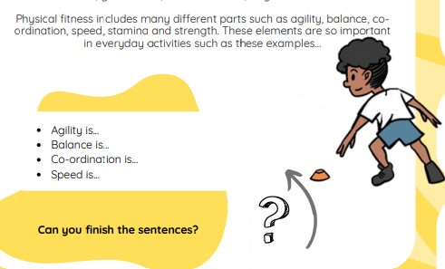 | Running  Keep your elbows bent when changing direction to help you to stay balanced  Balancing  Squeeze different muscles to help you to stay balanced in different activities  Jumping and Hopping  Swing your non-hopping foot helps to create momentum  Skipping  Keep your chest up to help you to stay balanced
agility | The ability to change direction quickly
Balance | The ability to maintain stability when stationary or when moving
Co-ordination | Moving two or more body parts at the same time
Control | Being able to perform a skill with good technique
Decelerate | Slow down
Decelerate | Slow down | Writing/Provision/  Enrichment opportunities
Distance | The measurement of space | Writing/Provision/  Enrichment opportunities
Distance | The measurement of space | Children will have access to the following equipment at playtimes and lunchtimes in order to apply the skills they have learned in their Pe lessons.  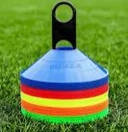  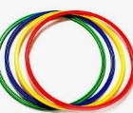  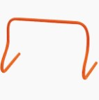  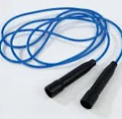  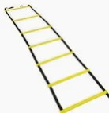
Momentum | The direction created by weight and power
React | To respond quickly
Stability | balanced

