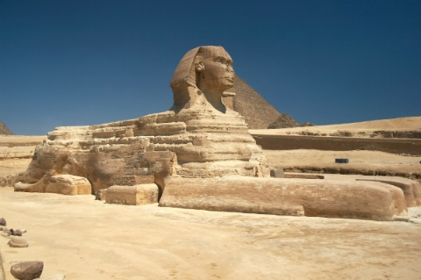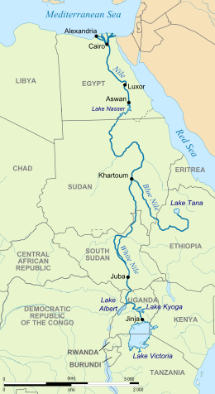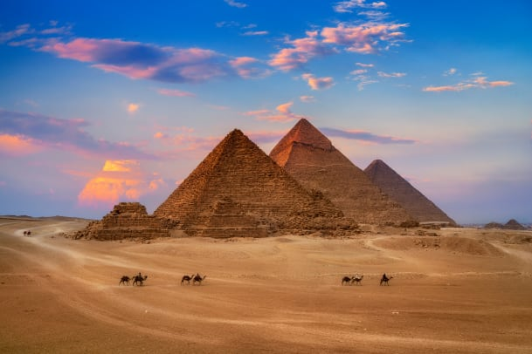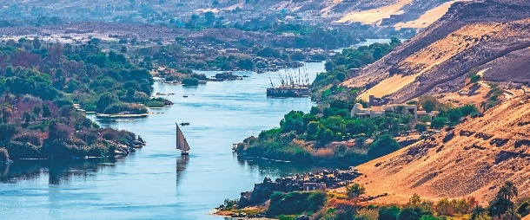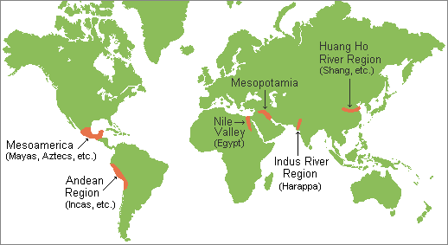

The Sphinx

A map of the River Nile

The Pyramids of Giza

**Why live close to a river?**

* Drinking water
* Washing
* Watering crops
* Catching fish
* Travel and trade
* Defend from attack
* Building materials
* Used as a calendar

**Other Key Vocabulary**

Nomadic

Monsoon

Floodplain

Barter

Sanskrit

Ganges

Buddhism

City-state

Dynasty

Irrigation

Acupuncture

Bamboo

Terracotta

Yellow River

Ritual

Bronze

Peasant

**Ancient Sumer Timeline**

**5000 BC** – Sumerians make their home in Mesopotamia

**4000 BC** – Temples to Sumerian gods are built.

**3300 BC** – The Sumerians invent a form of writing

**3200 BC** – The wheel is invented

**3000 BC** – Sumerians develop a form of mathematics

**Indus Valley Timeline**

**3300 BC** – Farmers settle in the Indus Valley region.

**3200 BC** – A form of writing is developed.

**2650 BC** – Homes are built from mud bricks including sophisticated drainage system.

**2600 BC** - Ploughs are used for farming

**1500 BC** – The Indus Valley comes to an end.

**Shang Dynasty Timeline**

**1776 BC** – Emperor Cheng Tang takes charge of the Yellow River area.

**1700 BC** – The Shang Dynasty begins using Bronze to make tools and weapons.

**1250 BC** – Animal bones are used to write on.

**1046 BC** – Slaves of the Shang revolt and overthrow the emperor

**Ancient Egyptian Timeline**

**6000 BC** – The first settlers make their homes around the River Nile

**3200 BC** – Hieroglyphs are first used to record trades

**2630 BC** – The first pyramid is built

**2550 BC** - The great pyramids of Giza begin construction.

**2558 BC** – Construction of the sphinx begins

**2000 BC** – Oxen and ploughs are first used in farming.

**1539 BC** – The Valley of the Kings begins construction and many great pharaohs rule Egypt for many years

**1332 BC** – The Pharaoh Tutankhamun begins his ten year rule

**1017-332 BC** – Egypt is invaded and taken over by several different invading forces including Nubians, Persians and Alexander the Great from Macedonia

**196 BC** – The Rosetta Stone is carved

**51 BC** – Cleopatra becomes Pharaoh of Egypt

**30 BC** – The Roman Empire invades Egypt and the rule of the Pharaohs comes to an end.

**Ancient Egyptian Key Vocabulary**

Pharaoh

Scarab

Papyrus

Scribe

Amulet

Canopic jar

Sarcophagus

Tomb

Afterlife

Hieroglyphics

Mummification

Irrigation

Shaduf

Sphinx

Oasis

Egyptologist

Ankh

Pyramid

Barter

Rosetta Stone

How have ancient civilizations influenced us today?