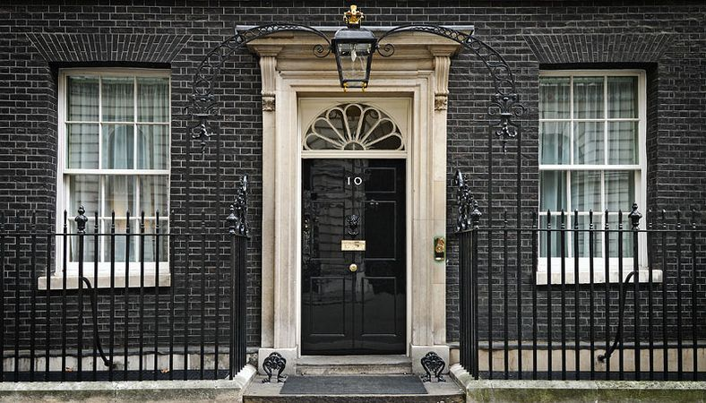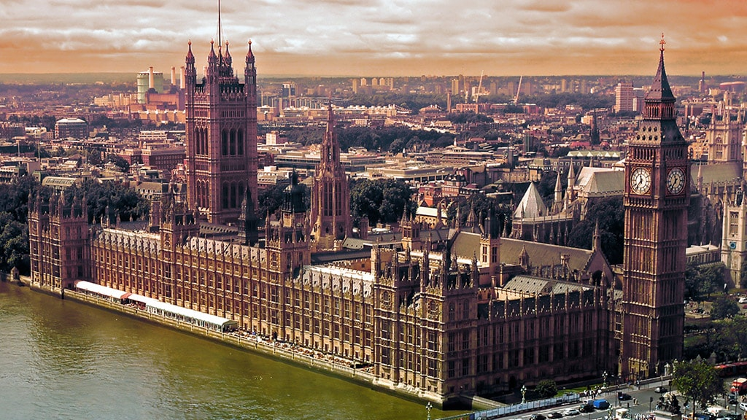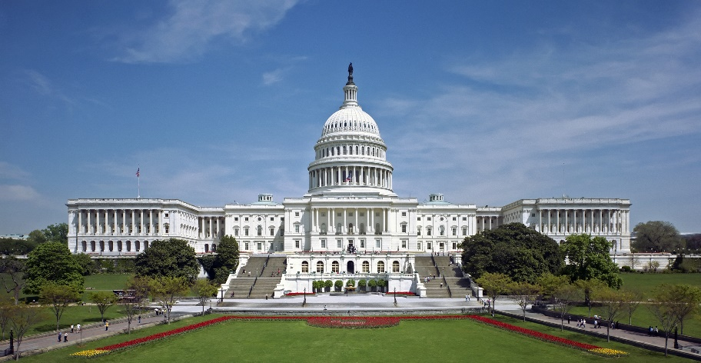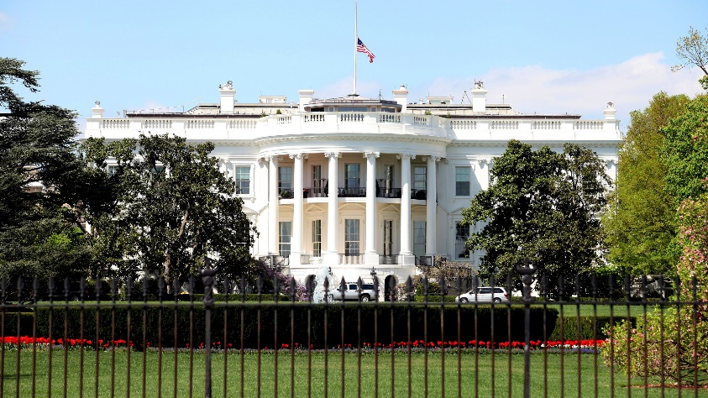

**US Government**

The President of the United States of America (often shortened to POTUS) is the head of state, and head of government of the United States. The office of President was created in the United States Constitution in 1788.

The federal government of the United States has three branches of government: the legislature, executive, and judiciary, as established in the United States Constitution.

**UK Government**

The Prime Minister is the leader of Her Majesty’s Government and is ultimately responsible for all policy and decisions.

The Prime Minister also:

* oversees the operation of the Civil Service and government agencies
* appoints members of the government
* is the principal government figure in the House of Commons.

The Capitol Building

10 Downing Street

Houses of Parliament

**Washington D.C. Key Vocabulary**

Ballot

Vote

Candidate

Campaign

Voting Booth

Election

Caucus

Delegate

Democracy

Democrat

Republican

Election

Electoral College

Voter

Incubant

Lobbyist

Primary

President

Primary

Swing Vote

Term

**London Key Vocabulary**

Act

Big Ben

House of Commons

Democracy

Gunpowder Plot

House of Lords

MPs

Order

Prime Minister

Rights and Responsibilities

Suffragettes

Parliament

Ballot

Vote

Westminster

Government

Political Party

Cabinet

Election

The White House

What is the difference between London and Washington D.C.?