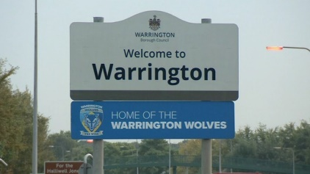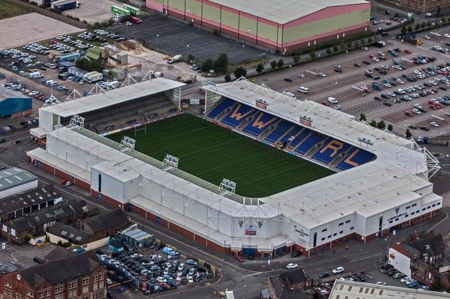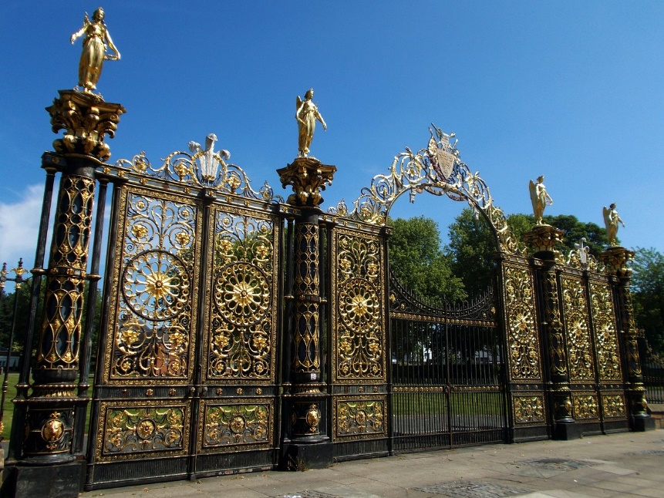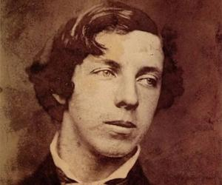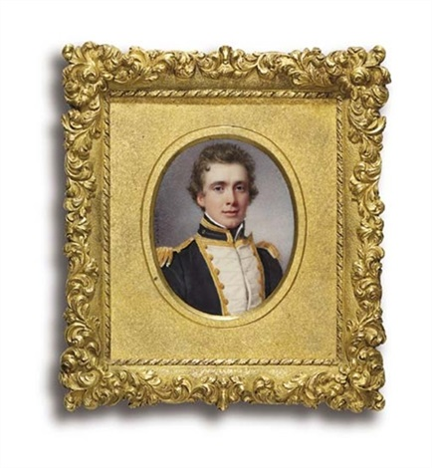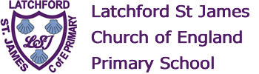

Halliwell Jones Stadium

The Golden Gates

Thomas Boteler

Lewis Carroll

Jesse Lingard

Some famous people from Warrington

**Key Vocabulary**

What is Warrington Famous For?

**A Brief History of Warrington**

1086 - The Domesday Book describes 'Walintune', a village near the ford over the Mersey at Latchford and Howley

1321 - Warrington becomes the first paved town in Lancashire

1526 - Boteler Grammar School is founded

1648 - Oliver Cromwell stays in Warrington

1757 - The 'Warrington Advisor' becomes Lancashire's first newspaper

1779 - The first Sunday school in the county, St James' Sunday School, opens

1834 - The first Warrington Walking Day

1848 - The first public library in the country is opened in Warrington, and the town's museum

1895 - The golden gates are officially opened at the front of Warrington Town Hall

1895 - The Parr Hall, designed by William Owen, opens

1897 - Victoria Park opens

1899 - A cast iron statue of Oliver Cromwell, by John Bell, is erected outside the Warrington Academy

1925 - The war memorial, or cenotaph, is unveiled at Bridgefoot

1934 - Kingsway Bridge opens over the River Mersey in Latchford

1974 - Warrington Market moves to Bank Street, and the Golden Square opens

1987 - Ikea opens in Warrington, its first British store

1995 - The Tim Parry Johnathan Ball Foundation for Peace is launched following the IRA bombings