Autumn Term, Year 1, PE Knowledge Organiser
Dance 1
Subject specific  Vocabulary |  | Images/Diagrams/Maps | Important Knowledge
Action | Something that someone does | 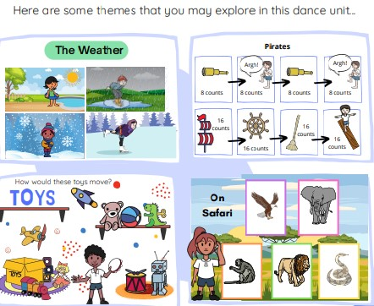 | Actions  Actions can be linked to create a dance.  Dynamics  You can create fast and slow actions to show an idea.  Space  There are different directions and pathways within space.  Relationships  When dancing with a partner it is important to be aware of each other and keep in time.  Performance  Stand still at the start and the end of the dance it will let the audience know when you have started and when you have finished.
Balance | Staying steady and not falling over
Beat | Steady sound or rhythm that you can clap, tape or move to.
Copy | Do the same as someone else or make something look the same
Counts | Say numbers in order or find out how many there are
Direction | The way something goes or points.
Direction | The way something goes or points. | Writing/Provision/  Enrichment opportunities
Level | How high or low something is | Writing/Provision/  Enrichment opportunities
Level | How high or low something is | Children will have access to the following equipment at playtimes and lunchtimes in order to apply the skills they have learned in their Pe lessons.  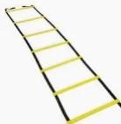  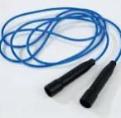    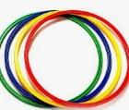  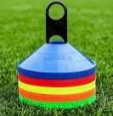
Pathway | A way or track to go from one place to another
Pose | Stay still in a position with your body
Timing | Doing something at the right moment

Autumn Term, Year 1, PE Knowledge Organiser
Fitness 1
Subject specific  Vocabulary |  | Images/Diagrams/Maps | Important Knowledge
Active | Moving around a lot or doing something energetic. | 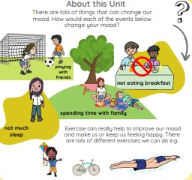 | Agility  Bending your knees will help you to change direction.  Balance  Looking ahead will help you to balance.  Co-ordination  Using the opposite leg at the same time helps you to perform skills such as running and throwing.  Speed  Swinging your arms will help you to run faster.  Strength  Exercise helps you to become stronger.  Stamina  Moving for a long time can make you feel hot and breathe faster.
Breathing | Taking air into your body and letting it out
Exercise | Moving your body to help it stay healthy and strong
Healthy | Feeling goof and strong because you take care of your body
Memory | Remembering things you have seen, heard or learned
Muscles | The parts inside your body that help you move.
Muscles | The parts inside your body that help you move. | Writing/Provision/  Enrichment opportunities
 |  | Children will have access to the following equipment at playtimes and lunchtimes in order to apply the skills they have learned in their Pe lessons.

