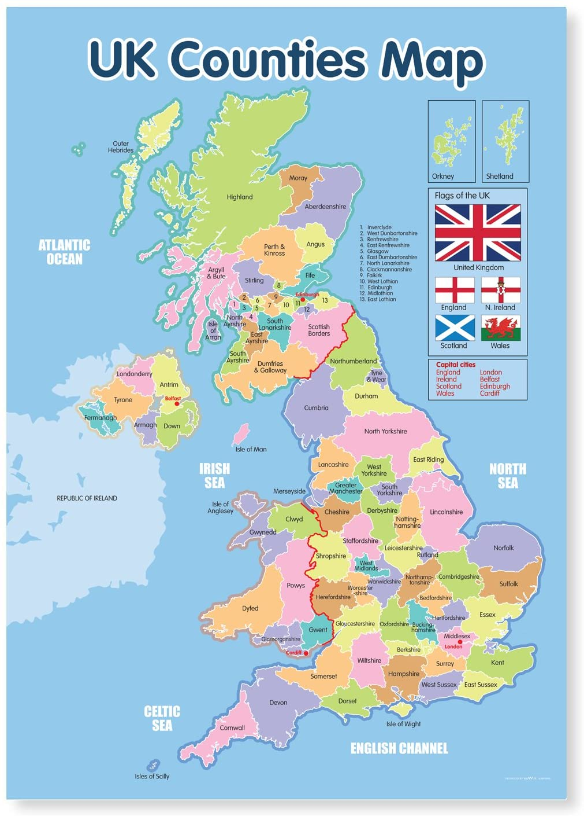

**Key Vocabulary**

capital cities

climate zones compass

human features landscape

land use

locality

map

mountain range north east

north west Northern Hemisphere Ordnance Survey physical feature region

south east

south west

What is the UK?

* **UK: United Kingdom** is an European country that includes four separate countries on the British isles: England, Northern Ireland, Scotland and Wales.
* **Great Britain** is the name for three nations on the main isle: England, Scotland and Wales
* **Britain** is used only for including the mainland countries England and Wales
* **Population**: about 66 million people live in the United Kingdom (2020)
* **Capital**: London with 9 million inhabitants
* **Name**: United Kingdom of Great Britain and Northern Ireland
* **Government**: Parliamentary Monarchy, Democracy
* **Language**: English
* **Religion**: mainly Christians 60%
* **Currency**: 1 British Pound (GBP) = 100 penny
* including the mainland countries England and Wales