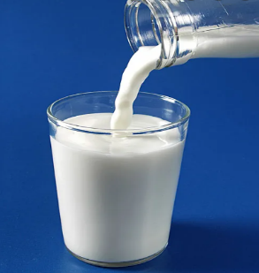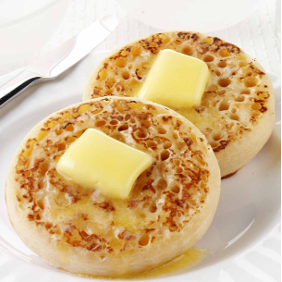

**School Snack list and prices**

Snacks can be ordered daily at registration. These snacks are prepared and served by the kitchen staff. Payment for these items is through Parent Pay.

**Milk (bottle) – 32p**

**Water (bottle) – 35p**

**Apple or Orange Juice – 35p**

**Toast – 30p**

**Crumpet – 35p**

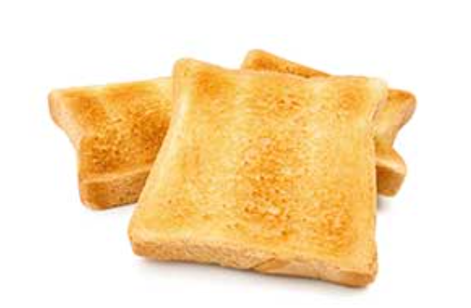**Toasted Teacake – 35p**



