**Collective Worship Policy**



| Written by | Grace Mellor |
| --- | --- |
| Signed by Chair of Governors | SKM_2_Page_1 (2) |
| Signed Headteacher |  |
| Date | April 2024 |
| Review Date | April 2026 |

**1. INTRODUCTION**

At Latchford St James CofE Primary School, collective worship is viewed as a unifying experience where all faiths come together to delve into and rejoice in passages from the Bible, song and prayer. It serves as a platform for discussing Christian values and their practical application in everyday life, while also establishing connections between contemporary events and the teachings of Jesus in the Bible. This holistic approach fosters an environment where pupils and adults can engage in meaningful conversations about God, both individually and collectively, nurturing a deeper understanding of faith.

We aim for students at Latchford St James to depart with a deep understanding and appreciation of Christianity, empowering them to incorporate its teachings into their daily lives. Through collective worship, which encompasses prayer, Bible study, song, sacraments, and exposure to the diverse cultural and artistic facets of Christianity, we provide a crucial avenue for this enrichment.

‘*Based on: The Church of England Education Office, Church of England Vision for Education: Deeply Christian, Serving the Common Good. (The Church of England Education Office 2016) page 10’*

This gathering through worship is inviting, embracing, and uplifting. It's an approach designed to cater to the needs of everyone, regardless of where they are on their spiritual journey. The law requires that there be a daily act of worship which should be *‘wholly or mainly of a broad Christian character’* [Ed. Ref. Act 1988] and in accordance with the school’s trust deed.

Our collective worship policy strengthens and nurtures the Christian identity of our school, reiterates our vision, and underscores our Christian values while also emphasising the significance of each child's role within our community. Our worship embraces the traditions within the Church of England and honours the Christian liturgical calendar through commemorative events. The daily act of Christian worship stands at the core of our ethos, backed by the support of our staff and governors. It significantly contributes to the development of our entire school community—spiritually, morally, socially, and culturally.

**2. RATIONALE - INCLUSIVE, INVITATIONAL, AND INSPIRING**

In a busy Primary school, setting aside time for children to gather and foster a sense of belonging and community, is paramount. Collective worship provides time to shape our ethos as a Christian community and serves as an occasion to honour our school's Church Values.

Inclusive:

Inclusivity is at the heart of our worship. It entails coming together, exploring ideas, questioning, and responding. Within our Church school, pupils, their families, and other members of the community can expect worship that is welcoming and fully accessible to everyone. Given the diverse faith backgrounds as well as no background, among our students and staff, it's crucial to acknowledge and accommodate varying stages of spiritual development. Pupils should feel empowered to think critically, ask questions, and express consent or dissent. Careful attention must be paid to the language used during worship, ensuring it doesn't presume faith among all participants.

Collective worship isn't something imposed upon the school community but rather a collaborative endeavour that involves meaningful contributions from all, including students, staff and governors. It's understood that each pupil brings their unique experiences to the table. Inclusion necessitates active involvement of students in the planning, leadership, and evaluation of worship especially through the Ethos team.

Invitational:

Parents, pupils, and adults can expect an inclusive approach to worship especially through its welcoming nature. There should be no pressure to participate actively; instead, worship should offer opportunities for engagement while respecting the freedom of those from various faith backgrounds or those with no religious affiliation to be present and engage. Participants, whether students or adults, should only be encouraged to pray if they choose to do so, and they should be encouraged to pray in their own manner. Additionally, there should always be room for reflection alongside prayer.

The musical and liturgical elements incorporated into worship should embody both the traditional and contemporary aspects of Anglican worship, aligning with the christian values. Musical selections should reflect the diverse worship practices within the broader Christian community.

Inspiring:

In a Church school, both pupils and adults can anticipate encountering worship that is uplifting. Worship should serve as a means of personal and communal growth. It should inspire both students and adults to take action, to challenge conventional thinking, and to reflect on their own behaviour and its impact on the broader community. Through collective worship, participants should feel empowered to become bold advocates for meaningful causes, prompting deep reflection about their faith and beliefs. While our school aims to create an inclusive environment for worship, it's acknowledged that some may feel uneasy about participating. Therefore, the Church of England acknowledges the right of parents or pupils to opt out of collective worship if they so choose. Details on how to exercise this option are provided below (section 12).

**3. LEGAL REQUIREMENTS & ENTITLEMENT**

We acknowledge the legal requirement that there must be a daily act of worship for

all pupils. The act of worship is not designated curriculum time and will not be

subsumed under any part of the curriculum, including religious education. In this

school, as with any Voluntary Aided School, responsibility for arranging Collective

Worship rests with the Governing Body after consultation with the Senior

Leadership Team. The Governor’s recognise that in line with the Education Act of 1998, Parents and Guardians can choose to withdraw their children from acts of worship.

**THE AIMS OF COLLECTIVE WORSHIP**

Collective Worship aims to provide pupils and school staff the opportunity to:

• Engage in an act of community

• Express praise and thanksgiving to God

• Be still and reflect

• Explore the big questions of life and respond to national events

• Foster respect and deepen spiritual awareness

• Reflect on the character of God and on the teachings of Christ through Biblical

texts

• Affirm Christian values and attitudes

• Share each other’s joys and challenges

• Celebrate special times in the Christian calendar

In line with the requirements of the Statutory Inspection of

Anglican and Methodist Schools (SIAMS) framework 2023, we aim to ensure that

collective worship responds to the following:

Q3 How is collective worship enabling pupils and adults to flourish spiritually? (can be found in the schools SIAMs action plan)

* a) How do the theologically rooted Christian vision and the Anglican/Methodist
* Does the foundation of the school shape worship and spirituality in the school?
* b) How do partnerships with the DBE and/or MAST, and partnerships with
* parish/local church/es enhance this?
* c) In what ways is the worship life of the school inclusive, invitational, and
* inspirational?
* d) In the context of the school as a Church school, what do pupils and adults
* understand the meaning of spirituality? How does this enhance and enrich
* collective worship and individuals’ spiritual development?

The Anglican Christian Tradition.

The following are shared as Christian elements of collective worship:

* Exploring the Christian understanding of God as Father, Son and Holy Spirit
* Using the Bible for inspiration, stories and guidance
* Observing the cycle of the Church’s Year – Harvest, Advent, Christmas, Lent, Easter,
* Pentecost and Saints Days amongst ordinary days
* Learning and saying prayers from a number of sources, in particular the
* Lord’s Prayer.
* Singing a wide variety of hymns and songs from traditional to modern
* Experiencing Christian symbols in worship and reflecting on their meaning
* The use of prayer, silence and reflection

We may also use elements which are more distinctively Anglican:

* Using prayers from Common Worship
* Using Anglican sentences and responses at the beginning and end of worship
* Celebrating Eucharist

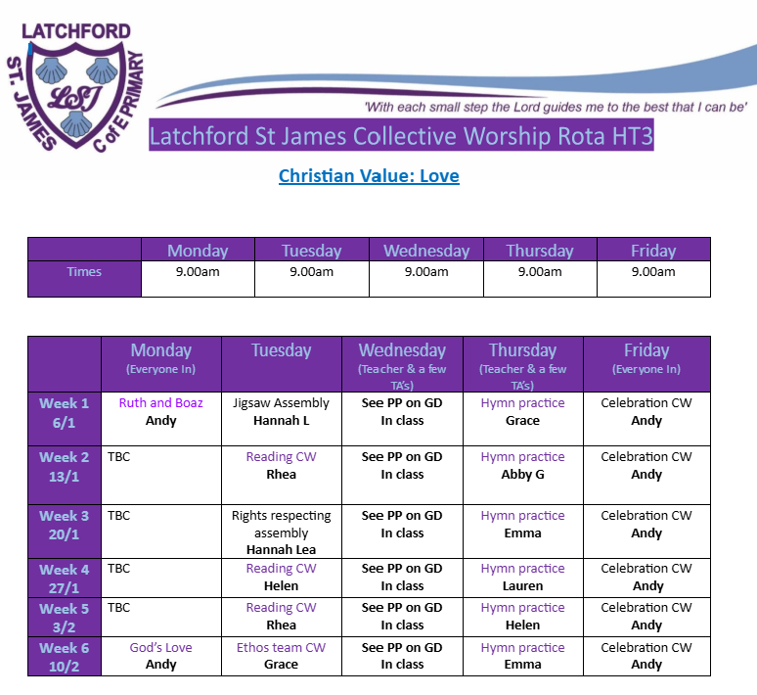

**5. IMPLEMENTATION**

Collective worship at our school is organised by the RE lead, with approval from the headteacher, staff, and governors. It occurs daily, with whole-school collective worship held in the hall on Monday (9am), Wednesday (10:15am), Thursday (10:15am), and Friday (9am), led by a teacher, member of the Senior Leadership Team, or a governor. On Tuesdays, class-based collective worship can happen at any point during the school day and is typically led by a teacher or a member of the ethos team.

An example of our Collective Worship rota can be found here:

We have 6 Christian values that we focus on throughout the year:

HT1 – Friendship

HT2 – Peace

HT3 – Love

HT4 – Hope

HT5 – Honesty

HT6 - Respect

Visitors to our school are asked to read and comply with our school visitor and safeguarding policies. This should include discussing the content of any worship with a member of the senior leadership in order to ascertain its suitability for the school community. Visitors are never left alone with children as the supervision of pupils remains the responsibility of school staff.

**6. RIGHTS RESPECTING LINK**

Latchford St James C of E Primary School is proud to be a Rights Respecting school. UNICEF Rights Respecting Schools Award recognises our schools commitment to creating a safe and inspiring place to learn, where children are respected. Developing a Rights Respecting ethos in all our school ensures that these values are embedded in daily school life, providing opportunities for children to explore and develop their culture, language and religion (article 30). Linking to article 14, children also have the freedom of thought and religion.

**7. EXPECTATIONS OF PUPILS**

As part of their duties as members of the Ethos team, pupils plan and lead at least one collective worship half termly. They work with the RE/Collective worship leader to develop their own understanding of worship and to design a worship to support the spiritual development of their peers.

**8. CHURCH EVENTS AND CELEBRATIONS**

Special religious occasions are discussed, planned and arranged by the RE lead, Head teacher, governors and Rev Rob throughout the year. Religious celebrations are held in Latchford St James CofE Church.

Celebration coincides with a festival from the ecumenical calendar, including:

* A Harvest festival at which the children contribute gifts or food for those less fortunate than themselves
* A Christmas Carol Service (KS2)
* An Ash Wednesday Service at which children and staff are given the Ashes
* An Easter service is performed during the Easter period
* A Leavers Service is held at the end of the school year.
* A service is held each year for pupils choosing to be Confirmed.

**9. DEVELOPING WORSHIP**

The school allocates part of its budget to support the daily act of collective worship.

The collective worship co-ordinator/ RE lead attends professional development and accesses a wide range of resources to ensure that worship is both inspiring and engaging. All teachers lead worship; therefore, we will be providing specific CPD from the diocese to all our teachers.

**10. DEVELOPING STAFF EXPERTISE AND KNOWLEDGE: CONFIDENCE THROUGH PROFESSIONALISM**

Parents, pupils, and adults deserve to be guided in worship by individuals who possess a secure knowledge of collective worship within the context of a Church school and who respect individuals from all faith backgrounds and those with none. Therefore, it's crucial to prioritise the development of expertise among staff, pupils, clergy, and other adults involved in leading collective worship in Church schools. To achieve this, the school should ensure the following:

1. Worship leaders, including clergy, should have access to regular training, primarily facilitated by local diocesan education teams.
2. Pupil worship leaders should be nurtured, supported, and provided with resources to contribute meaningfully to acts of worship.
3. Worship leaders, including clergy, should have access to high-quality and up-to-date resources.
4. The governing body should establish robust systems to effectively monitor the impact of worship, actively involving pupil voice in this evaluation process. Those leading worship should have the opportunity to receive feedback and understand the outcomes of these evaluations.
5. External agencies and church groups invited into the school to facilitate worship should adhere to these standards.

**11. SELF-ASSESSMENT AND INSPECTION**

Our school regularly evaluates our acts of collective worship and the impact it has on

the school and its wider community by linking our Christian Values to everything we do. This involves monitoring by school leaders, staff, pupils and governors in order to grow and develop. Pupil voice is taken half termly to review the effectiveness of Collective worship and the message which has been received by the pupils. Worship is independently inspected by law under Section 48 of the Education Act (SIAMS).

**12. PARENTAL WITHDRAWAL**

Worship holds a significant place in our school's ethos. It serves as an inclusive time for individuals of all faiths and those with none to come together. We fully respect parents' right to withdraw their child/children from collective worship activities. However, given the centrality of collective worship to our ethos, we would appreciate the chance to discuss this decision with parents.

When a parent/carer intends to withdraw their child/children, we kindly ask them to first contact the school office, allowing us the opportunity to respond appropriately. Formal withdrawal requests must be made in writing to the headteacher. The school maintains a neutral stance regarding parental choices in this matter. We will arrange alternative provisions to ensure compliance with the Education Act.

Written by

Grace Mellor

April 2024

**Edited CW timetable with updated timetable : 29.12.24**