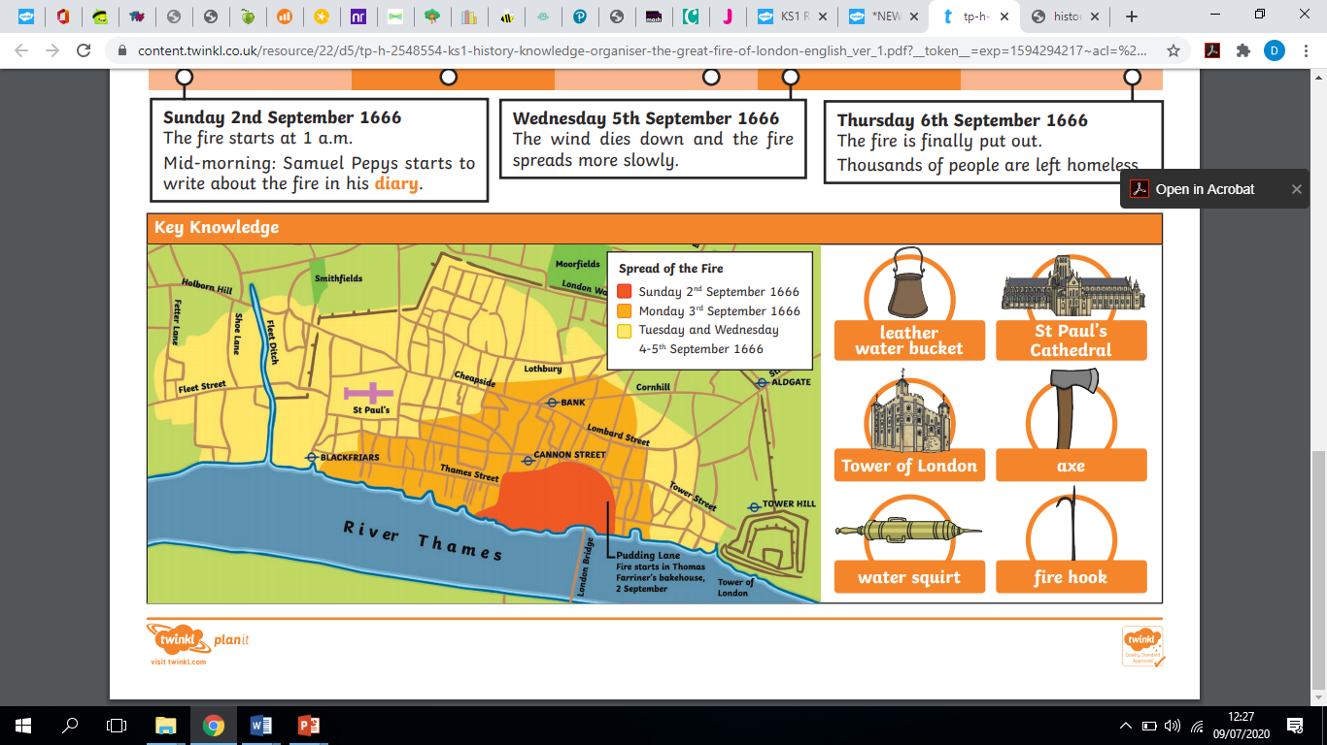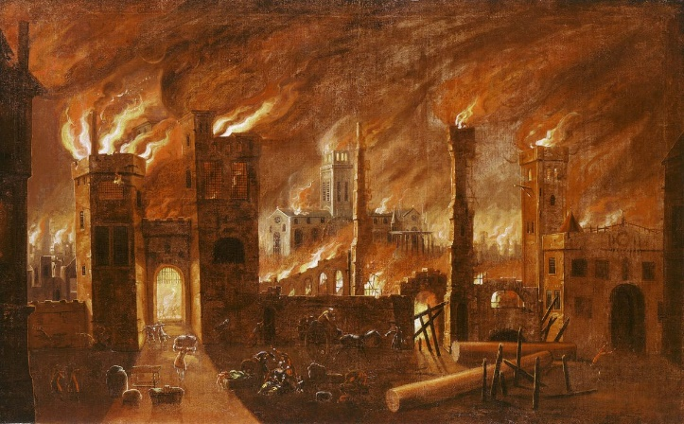

**Key Places**

Pudding Lane

The tower of London

London Bridge

The river Thames

St Paul’s Cathderal

**‘The great fire of London 1666’**

**Painted in 1670**

**Key People**

Samuel Pepys

King Charles II

Thomas Farriner

**Key Vocabulary**

Bakery

Leather bucket

Squirt

Fire posts

Fire hook

Gun powder

Thatched roof

Wattle and daub

Timber frame

Cathedral

Government

**Key Events of the Great Fire of London**

2nd September 1666

The fire starts at 1a.m

Samuel Pepys begins writing his diary

3rd September 1666

The fire spreads across London and gets close to the Tower of London

4th September 1666

St Paul’s Cathedral is destroyed by the fire

5th September 1666

The fire is starting to die down

6th September 1666

The fire is finally put out but thousands of people have lost their homes.

Why did London burn?