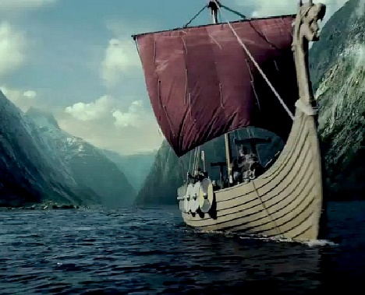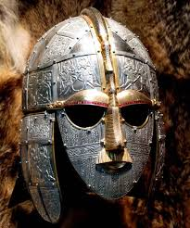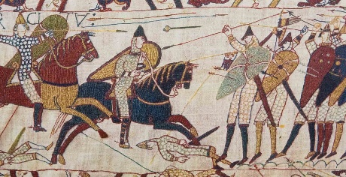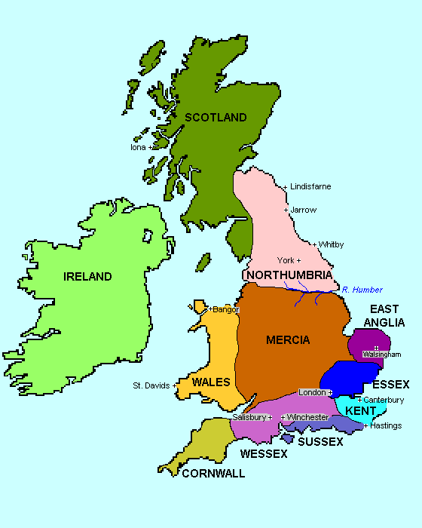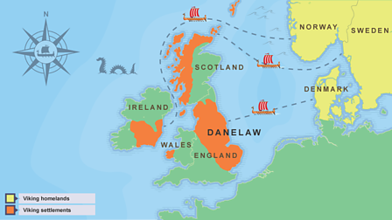

The Bayeux Tapestry

Anglo Saxon Britain

**Anglo Saxon Key Vocabulary**

Saxons

Mead

Rune

Wattle-and-daub

Thatch

Farmer-warrior

Sutton Hoo

Lindisfarne

Monk

Illumination

Manuscript

Christianity

Alfred the Great

**Viking Key Vocabulary**

Longboat

Longhouse

Chieftain

Berserker

Danegeld

Feast

Raid

Trade

Yggdrasil

Runes

Farmer-warrior

Pagan

Danelaw

Asgard

Figurehead

Chainmail

Valhalla

**Viking Timeline**

**793 AD** – A Viking raiding party attacks a monastery at Lindisfarne.

**794 AD** – Viking raiding parties attack parts of Scotland

**866 AD** – Vikings overtake the city of York, known as Yorvik by the Vikings.

**871 AD** – Alfred the Great becomes king of Wessex and drives invading Vikings out and to the north.

**878 AD** – by 878 the Vikings had permanently settled in Britain, overrunning Wessex and forcing King Alfred the Great in to hiding.

**886 AD –** King Alfred agrees a treaty with the Viking settlers. Alfred keeps the West and the Vikings take the East. They rename it Danelaw.

**900 AD** – The Vikings establish a rule over Scotland

**939 AD –**Vikings lead by Olaf Guthfrithsson invade England and take back the north.

**954 AD** – The last Viking King of Yorvik, Eric Bloodaxe is forced out of York

**1038 AD** – King Sven of Denmark and his son, Cnut, claim the throne of Danelaw and a year later become King of the Danes and of England.

**1042 AD** – Edward the Confessor becomes King of England

**1066 AD** – Edward the Confessor dies and Harold, earl of Wessex is crowned king

**1066 AD – 14th October** – The battle of Hastings if fought between Harold, King of England and William, duke of Normandy.

**Anglo Saxon Timeline**

**410 AD** – Roman soldiers withdraw from Britain leaving her mostly undefended and the Saxons arrive.

**600 AD** – The Saxons begin to spread around England and it is split into 4 regions; Northumbria (the north), Merica (the middle), East Anglia (the east) and Wessex (the south).

**793 AD** – A Viking raiding party attacks a monastery at Lindisfarne.

**871 AD** – Alfred the Great becomes king of Wessex and drives invading Vikings out and to the north.

**924 AD** – Alfred the Great’s grandson, Athelstan, becomes king of Wessex.

**927 AD** – Athelstan conquers the rest of the kingdoms and becomes the first king of England.

**937 AD –** Athelstan isn’t well liked and a rebellion begins. He defeats the rebels in battle.

**939 AD –** Athelstan dies and the Vikings lead by Olaf Guthfrithsson invade England and take back the north.

**1042 AD** – Edward the Confessor becomes King of England

**1066 AD** – Edward the Confessor dies and Harold, earl of Wessex is crowned king.

**1066 AD** – Harold Hardrada, King of Norway, and William, duke of Normandy both make claims to the throne of England.

**1066 AD – 14th October** – The battle of Hastings if fought between Harold, King of England and William, duke of Normandy. William is victorious and becomes King of England and is known as William the conqueror. This begins the Norman reign in England and the end of the Saxons.

Why did the Vikings come to Britain?