

School Uniform
It is important that ALL items of uniform and PE kit are labelled with your child’s name. We believe our uniform looks smart, is comfortable and practical and contributes to a feeling of pride in belonging to Latchford School.

For the school day

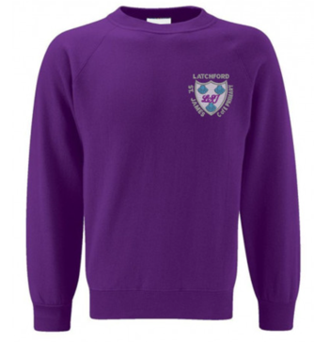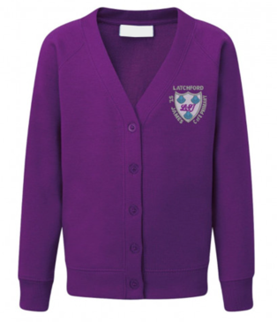
School purple sweatshirt/ cardigan*

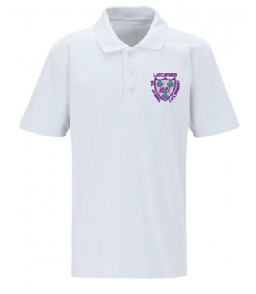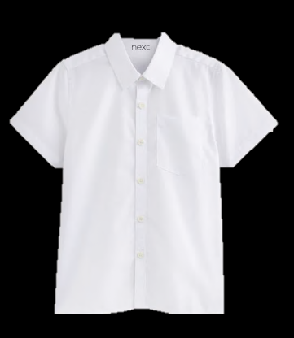
White school polo shirt/ white shirt

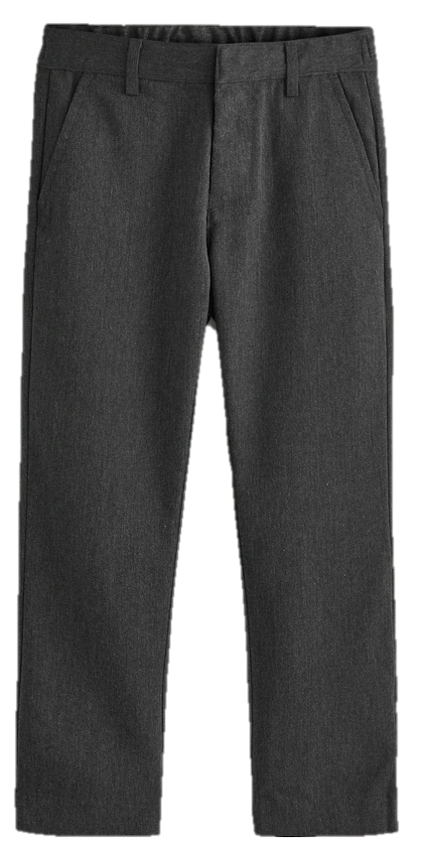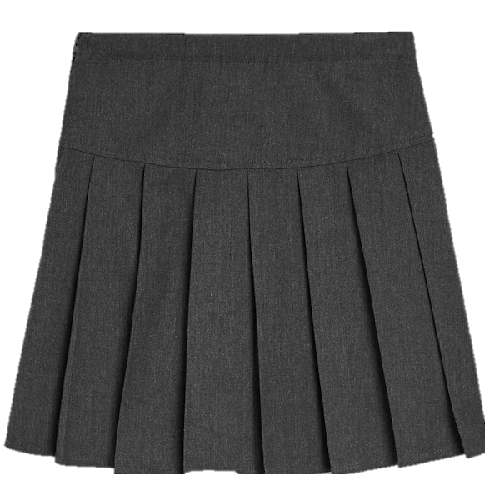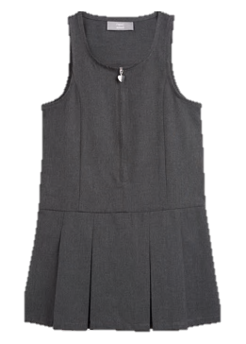
Grey trousers/ grey skirt/ grey pinafore

Sensible shoes (not trainers) – dark colour, flat and supporting
Grey/white socks or dark tights.
School purple fleece (optional)*

Summer option

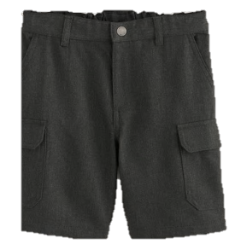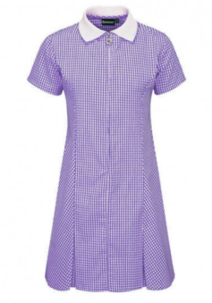
Grey school shorts Lilac gingham dress

PE kit
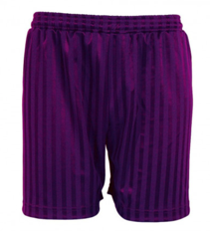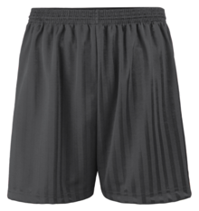
Purple shorts*/ black shorts

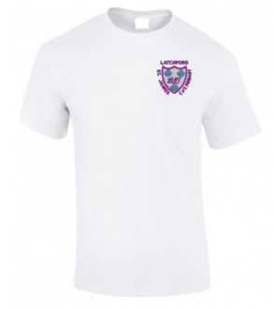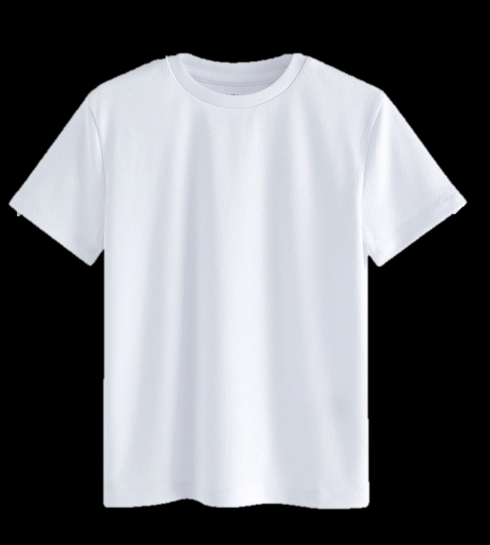
School logo white t-shirt or plain white t-shirt *

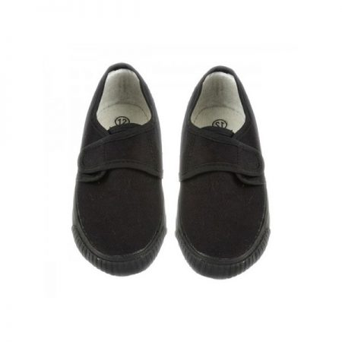
Change of shoes – pumps/trainers (Slip on pumps are easier for younger children)
Dark track suits/joggers for winter games (KS1 & KS2)
Socks for pupils who wear tights
Their PE kit should be kept in a named bag, preferably a draw-string pump bag and left in school at all times.
* Items with a star next to them are available for purchase from Touchline Ltd (online), or Warrington school wear (Warrington town centre)*
All items of clothing must be clearly labelled with the child’s name.
The wearing of jeans, football/rugby strip, track suits, Bermuda or cycling shorts is deemed unsuitable in school as daily dress. Similarly, children should not wear jewellery, except for simple ear studs and watches.

