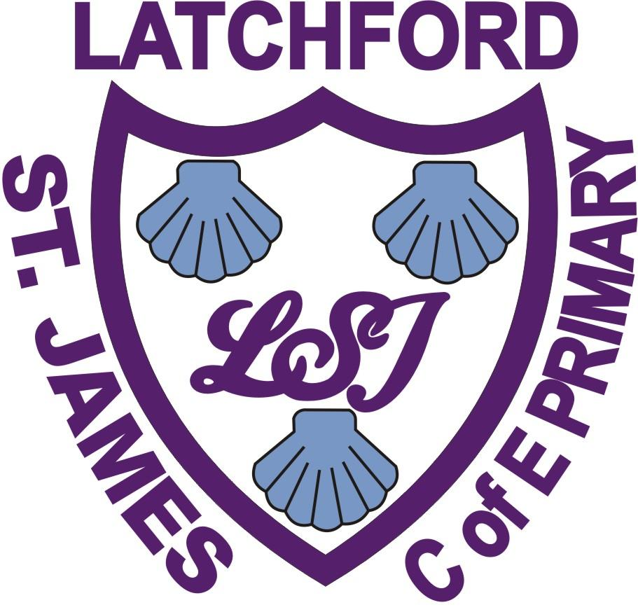
Early Years Foundation Stage (EYFS) Policy
Early Years
Foundation Stage & Transition
Policy
September 2020
Signed (Chair of Governors)………………………………………
Signed (Head teacher)………………………………………………
Date……………………………………………………………………
Review Date…………………………………………………………

The Early Years Foundation Stage (EYFS) applies to children from birth to the end of the Reception year. At Latchford St James C.E Primary School, children join our Nursery class when they are 3 years old and our Reception class when they are 4 years old. The children learn that they are part of the Christian community and Christian World. They are taught through a values led approach with God and Jesus at the centre of everything.

Introduction
The Early Years Foundation Stage education provides the foundation for the National Curriculum. Children develop quickly in the early years and a child’s experiences between birth and age five have a major impact on their future life chances. The quality of learning children experience in the early stages influences both their future attainment and their desire to learn. The EYFS sets the standards that all early years’ providers must meet to ensure that children learn and develop well and are kept healthy and safe. It promotes teaching and learning to ensure all children are ready for school and it gives the children the broad range of knowledge and skills that provide the right foundation for good future progress through school and life.

At Latchford St James C.E Primary School, we aim to make the EYFS environment a welcoming place. We try to create an atmosphere in which effective learning can take place by considering the individual needs, interests, and stages of development of each child in our care. We use this information to plan a range of individual challenging and enjoyable experiences in all areas of learning and development through continuous and enhanced provision. The Early Years department is well resourced and the children have the opportunity to learn both indoors and outdoors.

AIMS
This document is a statement of the aims, principles and strategies that guide teaching and learning in the Early Years Foundation Stage at Latchford St James C.E. Primary School. Our practice reflects the requirements of the Statutory Framework for the Early Years Foundation Stage (birth to five) and Development Matters /Early Outcomes. As an EYFS team, we endeavour to ensure that children “learn and develop well and are kept healthy and safe.” We aim to support children in their learning through “teaching and experiences that gives children the broad range of skills that provide the right foundation for good progress through school and in life.” (Statutory Framework for the EYFS April 2017)

- To give each child a happy, positive and fun start to their school life in which they can establish solid foundations on which to expand and foster a deep love of learning.

- To offer each child a wide range of new and exciting experiences and give them the opportunity to consolidate, explore and test them out along with their own, individual experiences.

- To enable each child, through encouragement and high expectations, to develop, to the full, socially, physically, intellectually and emotionally.

- To offer a structure for learning that has a range of starting points and unlimited opportunity for development.

- To encourage children to develop independence within a loving, secure and friendly atmosphere.

- To support children in building relationships through the development of social skills such as cooperation and sharing.

- To help each child to recognise their own strengths and achievements through experiencing success and developing the confidence to work towards personal goals.

- To support children in becoming confident, resourceful learners who are able to take risks within their learning.

- To ensure that children begin to develop an understanding of the teachings of Christianity to allow them to flourish in God’s love, aspire, achieve and be the best.

The EYFS is based upon four principles:
- A Unique Child
- Positive Relationships
- Enabling Environments
- Learning & Development

A Unique Child
At Latchford St James C.E Primary School we recognise that every child is a competent learner who can be resilient, capable, confident and self-assured. We recognise that children develop in individual ways, at varying rates. Children’s attitudes and dispositions to learning are influenced by feedback from others; we use praise and encouragement, as well as celebration assemblies and rewards, to encourage children to develop a positive attitude to learning.

Inclusion/Special Educational Needs (SEN)
All children are treated as individuals and have equal access to all available provisions. They are encouraged to achieve their personal best and planning is adapted to meet the needs of all groups and abilities. Assessments take into account contributions from a range of perspectives to ensure that any child with potential special educational needs is identified at the earliest possible opportunity. Early identification of special needs is crucial to enable staff to support the development of each child. Concerns are always discussed with parents/carers at an early stage and the schools SEN lead is called upon for further information and advice. We meet the needs of all our children through:
- planning opportunities that build upon and extend children’s knowledge, experience and interests, and develop their self-esteem and confidence using a wide range of teaching strategies based on children’s learning needs;
- providing a wide range of opportunities to motivate and support children and to help them to learn effectively;
- providing a safe and supportive learning environment in which the contribution of all children is valued;
- using resources which reflect diversity and are free from discrimination and stereotyping;
- planning challenging activities for children whose ability and understanding are in advance of their language and communication skills, and
- monitoring children’s progress and taking action to provide support as necessary.

Pupil Premium
Pupil Premium is additional funding which is allocated to schools on the basis of the number of pupils who have been eligible for free school meals (FSM) at any point over the last 6 years (known as ‘Ever 6 FSM’). Pupil Premium is aimed at addressing the current underlying inequalities which exist between children from disadvantaged backgrounds and their more affluent peers. Pupil Premium also provides funding for children who have been looked after for more than six months and the children of service personnel. At Latchford St James, the needs of any pupil receiving Pupil Premium will be planned to ensure that they have access to the curriculum and all available provisions. Children will be treated as individuals, where they will be encouraged to do their best and be given the best possible start.

Welfare
It is important to us that all children in the school are ‘safe’. We aim to educate children on boundaries, rules and limits and to help them understand why they exist. We provide children with choices to help them develop this important life skill. Children should be allowed to take risks, but need to be taught how to recognise and avoid hazards. We aim to protect the physical and psychological well-being of all children. (See Whole School Safeguarding Policy).

Positive Relationships
We recognise that children learn to be strong and independent from secure relationships. We aim to develop caring, respectful, professional relationships with the children and their families.

Parents as Partners
We recognise that parents are children’s first and most enduring educators and we value the contribution they make. We recognise the role that parents have played, and their future role, in educating the children.

Transition into EYFS from home/previous setting:
Members of staff conduct home visits before all children start Nursery, again with the primary purpose being to gather available information on the child to support transition. Nursery children then attend planned visits to the Nursery class, initially with their parent/carer and then independently to support them in settling in quickly.

For new children of the school who will start in Reception, staff will conduct a home visit. In addition to this, a member of staff will visit feeder settings for each child with the primary purpose of gathering available information on the child to support a smooth transition.

Children have the opportunity to spend time with their teacher in class before starting school during transition sessions in the Summer term prior to them starting in September. For the first week, children who are new to the school will attend for 3 half days.

Parents are invited to an induction meeting during the term before their child starts school to be introduced to their child’s teacher and to be given key information on the EYFS curriculum and the school day.

Transition through EYFS and into Y1:
Children have the opportunity to spend time with the new teacher before the start of the new academic year.

Parents are invited to an induction meeting during the term before their child starts Y1 to gather key information on Y1 curriculum and the school day.

Teachers have a meeting to discuss each child in detail, based on data, to support a smooth transition.

At Latchford St James C.E Primary School we are pro-active in developing home/school partnership and the following is in place:
- Regular parent meetings – a formal meeting twice a year at which the teacher and the parent discuss the child’s progress and next steps.
- Annual school report – a summary of the child’s progress over the year with targets of next steps in learning. In Reception this will also report on the how the child has met the early learning goals from the ‘Development Matters’ Framework.
- A variety of activities throughout the year that encourage collaboration between child, school and parents: stay and play sessions, worship, Church visits, Maths/English mornings celebration assemblies, school visits...
- Organised workshops to support home learning, particular focus on basic skills.
- Weekly home learning opportunities e.g. reading book, practical maths/writing activities...
- Opportunity to celebrate home learning by completing “WOW” moments which inform planning and provision.
- In partnership with parents and carers we enable the children to begin the process of becoming active learners for life.

Role of the adult:
Through regular CPD all practitioners working within EYFS are aware of the crucial role of the adult to ensure all children make ongoing progress.

Enabling Environments
At Latchford St James C.E Primary School we aim to create an attractive and stimulating learning environment where children feel confident and secure and challenged. Our aim is facilitated through the following:
- The children have daily access to an indoor and outdoor environment that is organised through workshops and discrete areas of learning with planned continuous provision to facilitate the consolidation of skills.
- Active learning is paramount and the learning environment is carefully planned to facilitate holistic learning across all areas of learning.
- A robust observation and assessment cycle informs planning, ensuring the environment is enhanced to provide challenge for all children to continue to make progress.
- Children have the opportunity to engage in purposeful reading, writing and mathematical opportunities across all areas of learning.
- To provide broad rich learning experiences practitioners plan educational visits into the local community (including regular visits to the school church and library).

Learning and Development
There are seven areas of learning and development all important and all inter-connected. These consist of three prime areas:

- Communication and Language (Listening and Attention, Speaking)

- Physical development (Gross Motor Skills, Fine Motor Skills)

- Personal, Social and Emotional development (Self-Regulation, Managing Self and Building Relationships)

and four specific areas through which the prime areas are strengthened and applied:

- Literacy (Comprehension, Reading and Writing)

- Mathematics (Number and Numerical Patterns)

- Understanding the world (Past and Present, People, Culture and Communities, The Natural World)

- Expressive arts and design (Creating with Materials, Being Imaginative and Expressive)

Characteristics of Effective Learning
The EYFS also includes the characteristics of effective teaching and learning. The Reception teachers plan activities within the Reception classrooms with these in mind. They highlight the importance of a child’s attitude to learning and their ability to play, explore and think critically about the world around them.

The characteristics are;
Playing and Exploring – children investigate and experience things, and ‘have a go’

Active Learning – children concentrate and keep on trying if they encounter difficulties, and enjoy achievements

Creating and Thinking Critically – children have and develop their own ideas; make links between ideas, and develop strategies for doing things.

Religious Education – Latchford St James C.E Primary School follows the Chester Diocesan Syllabus for RE. The children learn that they are part of the Christian community and Christian World. They are taught this through a values led approach with God and Jesus at the centre of everything.

The Early Learning Goals summarise the knowledge skills and understanding that the children should have gained in these areas by the end of the Reception year. The progress of all EYFS children is tracked against observation checkpoints to assess if the children are working ‘on track’ or ‘below’ for the age related expectations.

Teachers and teaching assistants implement the seven areas of learning (Prime & Specific) and Characteristics of Effective Learning across the daily routine. To ensure the maximum amount of progress for the maximum number of children for the maximum amount of time, a robust observation and assessment cycle is in place. Ongoing observation is embedded in daily practice with a focus on practitioners recording ‘significant’ observations to impact on learning. Gathered information, recorded and anecdotal is subsequently used to make accurate ‘best-fit’ assessment judgments against Early Year’s Outcomes. Regular moderation ensures accuracy of data across EYFS and as children transition into Y1. Analysis of data drives planning and indicates individual/groups of children for ‘narrowing the gap’ planning/strategies.

Across the daily routine, practitioners ensure children have a balance of child initiated and adult led activities (at least one Maths and English per week). Activities are appropriately differentiated to ensure ongoing progress.

Assessment/Recording/Reporting
The children entering EYFS are observed during their first weeks engaging in a variety of activities. From this and talk with parents/carers, their achievement on entry is recorded. EYFS will reference this to Development Matters/Early Outcomes.

The baseline assessment for pupils in reception is completed within the first weeks to measure their progress across their primary education.

Following this the children’s attainment in the seven areas of learning is continually assessed by means of observations: formal and informal observations, annotated pieces of work and teacher/teacher discussion or parental comment. Much evidence for attainment is gathered during the children’s independent work. The progress of every child is tracked each term and discussed with the head teacher.

Parents /carers are informed of their child’s progress each term by means of a parent or carer/teacher meeting and in the summer term a written report. Parents/carers and teaching staff also take advantage of our ‘open door ‘policy to discuss their children’s progress informally on a more regular basis. The children take home certificates and awards for good work, any matters of concern or need for additional help is discussed when the need arises.

Equal Opportunities
The well-being and progress of every child in our Foundation Stage class matters to us and as such all are treated fairly and with respect, as are their families. We are inclusive. We celebrate diversity and all the learning opportunities it brings.

Home School Partnership
We value our strong relationships with parents/carers and families of our pupils. All are welcome to come in and talk to us and we make every effort to reach out to all. We make it known that our door is always open, for those who don’t come to the school door we encourage them to telephone. We also send home home/school reading record books which parents/carers/teachers can also use as a means of communication. When necessary more communication can be planned.

