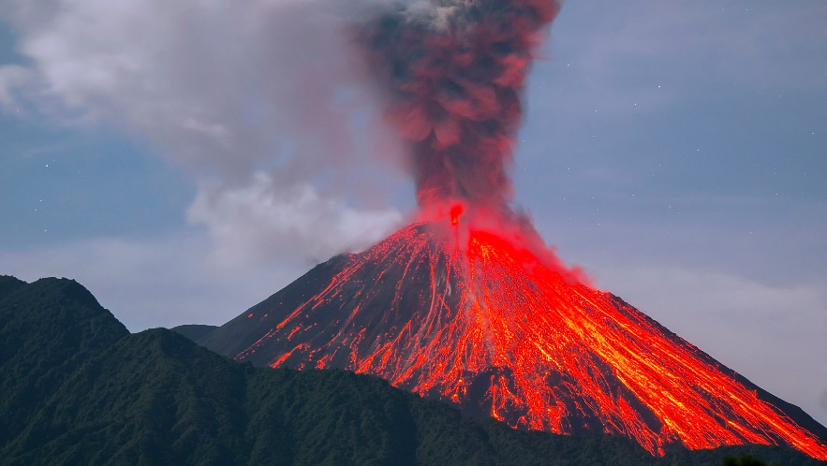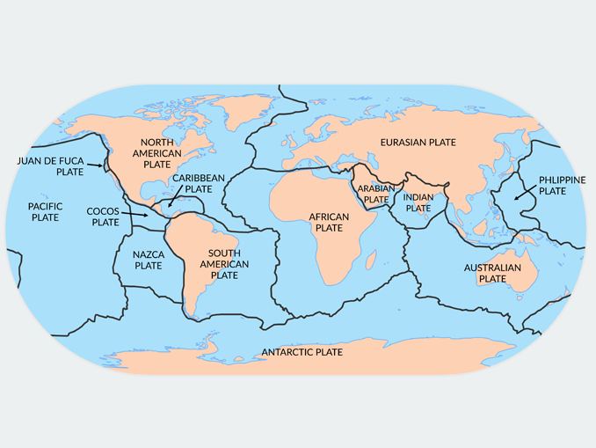

**Key Earthquake Vocabulary**

Crust

Epicentre

Inner core

Magnitude

Normal fault

Outer core

Reverse fault

Secondary waves

Seismic waves

Seismograph

Seismologist

Continental drift

Convection current

Plate tectonics

Hot spot

Fault

Fossils

**Key Volcano Vocabulary**

Active volcano

Ash

Vent

Crater

Dormant volcano

Eruption

Fault

Fissures

Geysers

Lava

Lava Flow

Magma

Molten rock

Mantle

Ring of Fire

Vent

Volcanic eruption

**Earthquake facts**

* Geologists rate earthquakes in magnitude, which is the amount of energy released during the quake.
* The largest recorded earthquake happened in Chile on May 22, 1960. It was a magnitude 9.5.
* The deadliest known earthquake happened in China in 1556. It killed about 830,000 people.
* Alaska has the record for the largest U.S. earthquake. On March 28, 1964, a magnitude 9.2 quake occurred and killed 131 people.
* Most earthquakes happen 50 miles (80 kilometers) or less below the Earth's surface. They can happen as deep as 400 miles (644 kilometers) below the surface.
* •Southern California has about 10,000 earthquakes a year. Very few are felt.

**Volcano facts**

* Put simply, a volcano is an opening in the Earth’s surface.
* The word “volcano” comes from the Roman name “Vulcan”.
* Volcanoes are often found at meeting points of “tectonic plates”.
* Approximately 350 million people live within “danger range” of an active volcano.

### Volcanoes are classified as active, dormant or extinct.

### Volcanoes don’t just occur on land.

### Lava from a volcano can reach 1,250°C!

### The world’s largest active volcano is Mauna Loa in Hawaii.

### In A.D. 79, the Italian town of Pompeii was destroyed and buried by a volcano called Mount Vesuvius.

What makes the Earth angry?