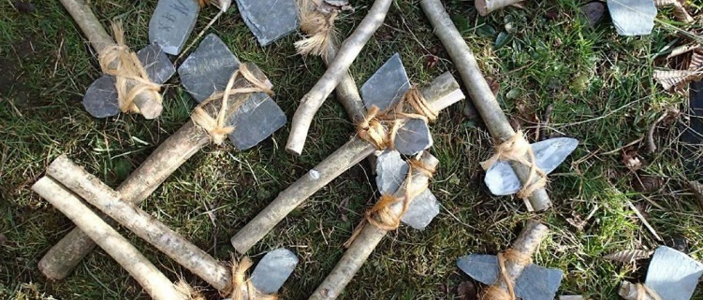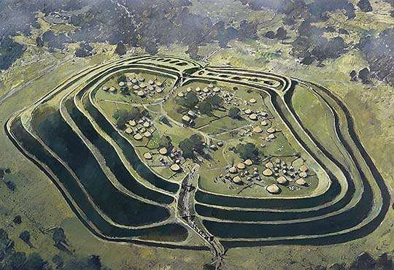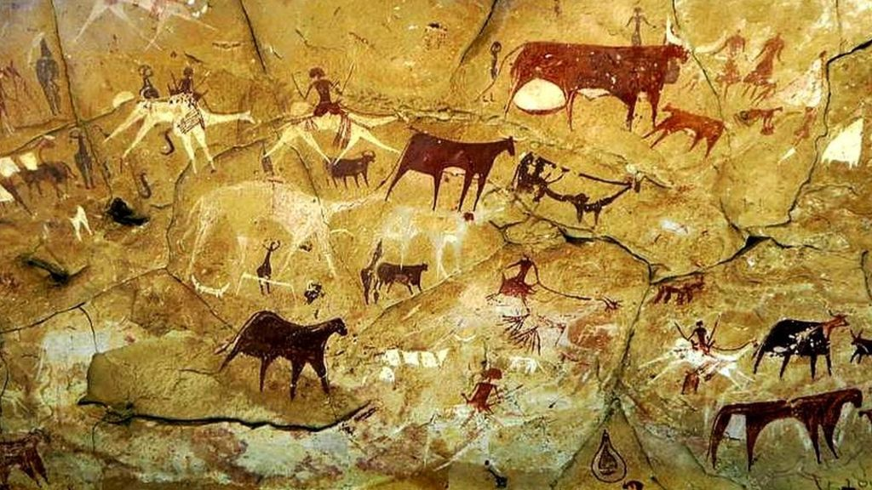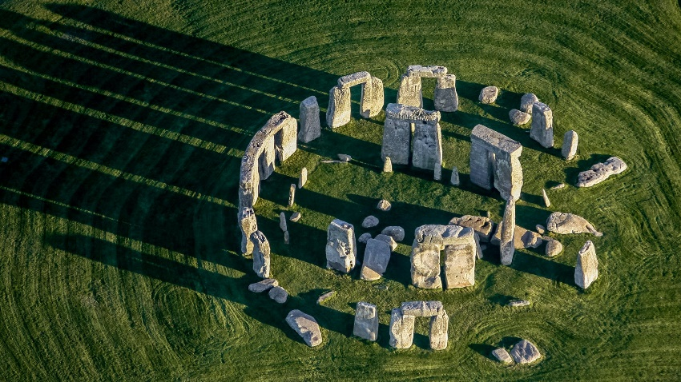

Stone age tools

A hillfort

Stonehenge

**Key Facts**

The Stone Age is divided into three periods; the Palaeolithic (old Stone Age), Mesolithic (middle Stone Age) and the Neolithic (new Stone Age).

Flint was commonly used for making stone tools but other stones such as chert and obsidian were also used.

The Bronze Age is the name given to the period of time between the Stone and Iron Ages.

Bronze is an alloy or mixture of tin and copper. Bronze alloy is harder than either of the metals from which it is made. It could be used to make a greater range of tools and weapons than had previously been possible.

Iron was tougher than bronze and could be shaped into finer and sharper objects. It required smithing (heating and hammering) to make into tools and implements.

A cave painting

**Stone Age to Iron Age Timeline**

**13,000 BC** – Some of the first cave paintings are thought to be done

**4500-3500 BC** – The first pottery is made and used as well as the first known uses of farming

**4000-3000 BC** – People begin to tame and ride horses.

**2500 BC** – Metal starts to be used to make tools out of.

**1800 BC** – The first copper mines are used.

**1200 – 800 BC** – Metal is being used much more in making weapons and tools. Celtic Culture begins.

**800 – 700 BC** – The first hill forts are made.

**700 – 500 BC** – Iron is used to make weapons and tools.

**100 BC** – The first coins are used

**43 AD** – The Romans invade Britain and bring with them many new inventions.

**Key Vocabulary**

Prehistory

Hunter-gatherer

Nomad

Palaeolithic

Mesolithic

Neolithic

Tribe

Neanderthal

Homosapiens

Pelt

Beaker

Celt

Bronze

Roundhouse

Hillfort

Quern

Smelting

Druid

Borer

Domesticate

How did Britain change from the Stone age to the Iron age?