Autumn Term, Year 5, PE Knowledge Organiser
Swimming
Subject specific  Vocabulary |  | Images/Diagrams/Maps | Important Knowledge
Buoyancy | When an object floats in water | 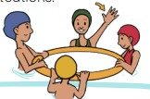 | Strokes  Pulling harder through the water will enable you to travel the distance in fewer strokes and travel faster  Breathing  Breathing every three strokes helps to balance your stroke and allows me to practise breathing on both sides  Water Safety  A group of people can huddle together to conserve your body head, support each other and provide a larger target for rescuers
Conserve | To protect something
Dolphin kick | Used the butterfly stroke, created by a whipping motion with the legs
Flutter kick | A kick used in crawl and backstroke in which the legs are extended straight back and alternatively moved up and down
Huddle | A position for two or more
Inhale | Breathe in
Inhale | Breathe in | Writing/Provision/  Enrichment opportunities
Propel | To move forward | Writing/Provision/  Enrichment opportunities
Propel | To move forward | Water Safety during Sports Week
Somersault | To rotate 360 degrees around a horizontal point | Water Safety during Sports Week
Streamline | The position you get your body in to flow through the water easily | Water Safety during Sports Week
Synchronised | When performers complete the same action at the same time | Water Safety during Sports Week

Autumn Term, Year 5, PE Knowledge Organiser
Basketball
Subject specific  Vocabulary |  | Images/Diagrams/Maps | Important Knowledge
Close down | To reduce the amount of space for an opponent | 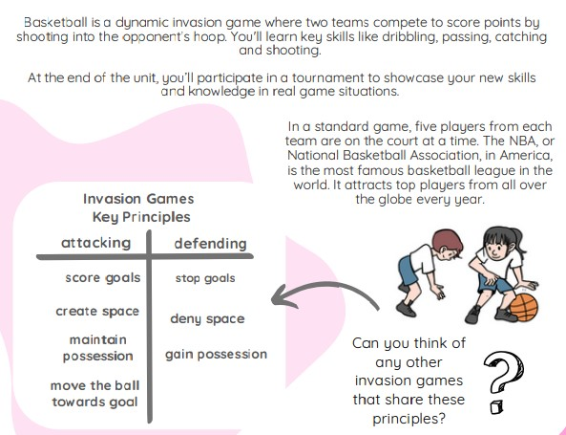 | Sending and Receiving  Not having a defender between you and the ball carrier help you to send and receive with better control  Dribbling  Dribbling in different directions and at different speeds will help you to lose a defender  Space  Moving to space even if you do not receive the ball will help to create space for a teammate
Decision | Select an outcome
Delay | To slow someone down
Deny | To prevent an action happening
Protect | To look after
Rebound | When a player attempts to shoot a goal but the ball hits the basket or backboard and bounces back into play
Rebound |  | Writing/Provision/  Enrichment opportunities
Receiver | The person collecting or stopping the ball | Writing/Provision/  Enrichment opportunities
Receiver | The person collecting or stopping the ball | Children will have access to the following equipment at playtimes and lunchtimes in order to apply the skills they have learned in their Pe lessons.  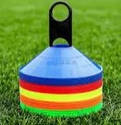  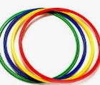  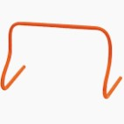  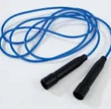  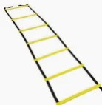
Sportsmanship | Play fairly, respect others and be gracious in victory and defeat
Tactics | A plan that helps you to attack or defend

