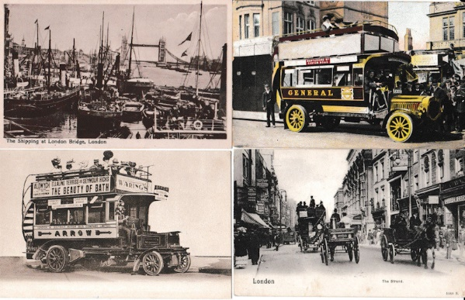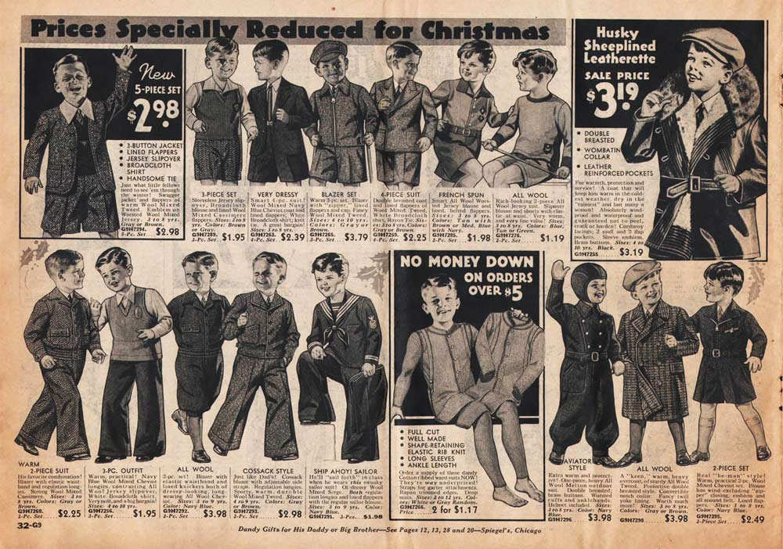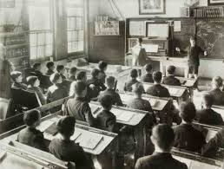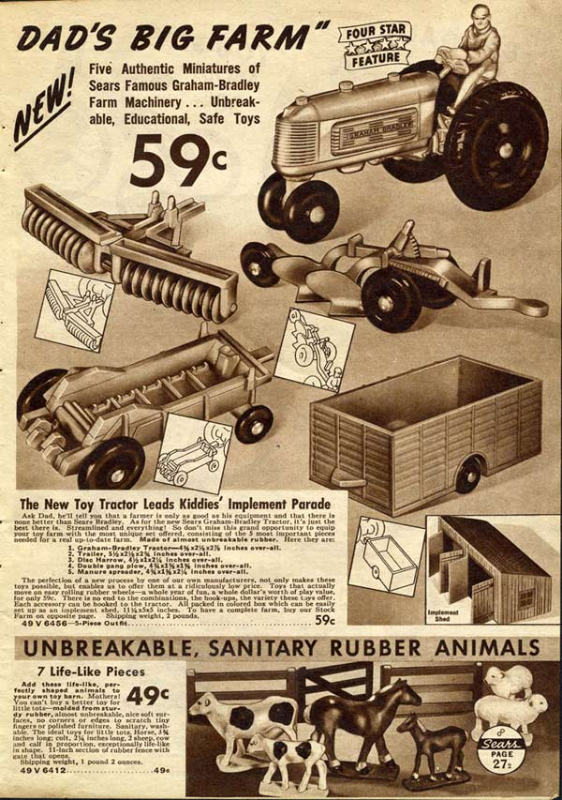

An advert for children’s clothing in 1930s

Some transport used in the 1930s

A school classroom in the 1930s

An advert for children’s toys

**Key Vocabulary**

a long time ago

when I was little

since I was born

when mummy and daddy were little

when gran and grandad were little

past

present

before

after

How has life changed in recent history?

**Key Events since 1930**

1930 – The planet Pluto is discovered

1939-1945 – World War 2

1948 – The NHS is founded

1953 – Queen Elizabeth II becomes queen

1958 – Lego is first released

1960 – The first motorway is opened

1966 – England win their first world cup

1967 – The first colour television broadcasts in Britain

1969 – The first man lands on the moon.

1972 – Newsround began

1979 – Post it notes and the first mobile phone were invented.

1989 – The internet was invented.

1994 – The first Playstation was released

1995 – The channel tunnel is opened.

2003 – Conchord makes it’s last flight

2012 – London hosts the Olympic games

2015 – Time Peake leaves earth for the international space station