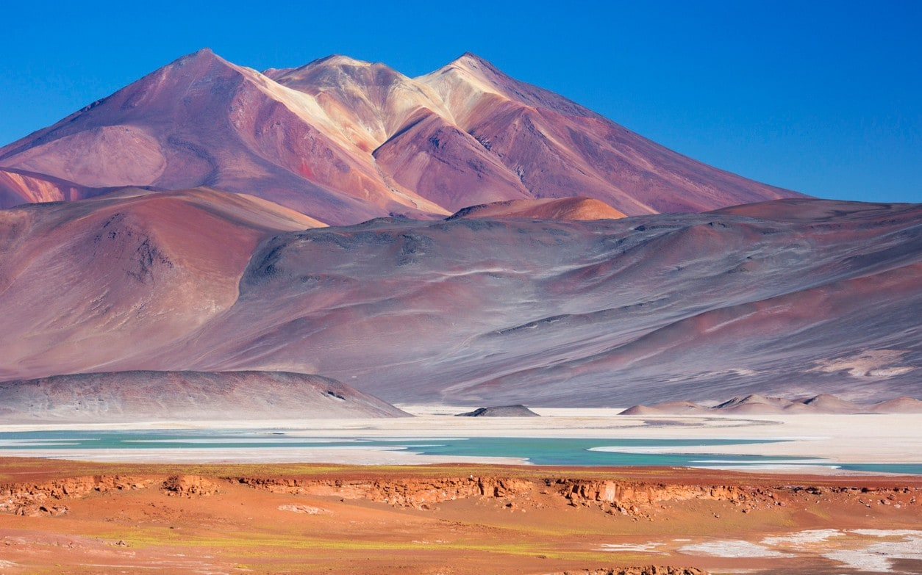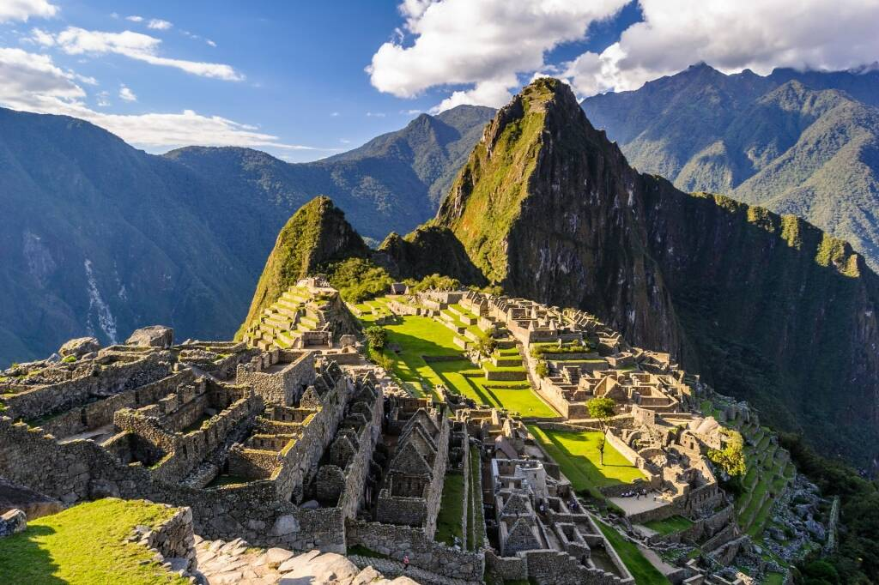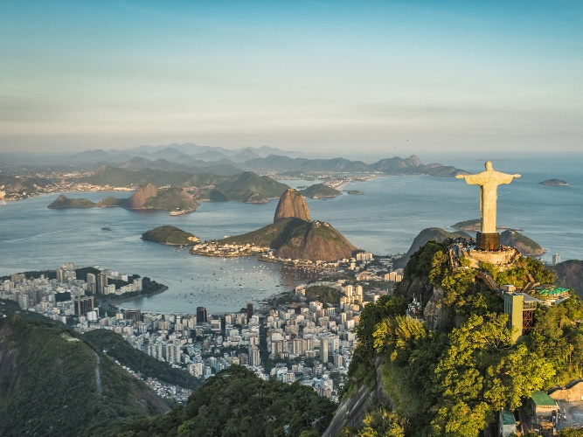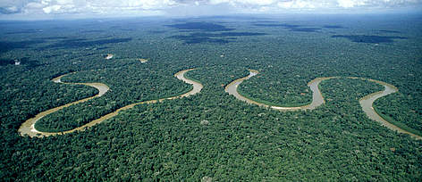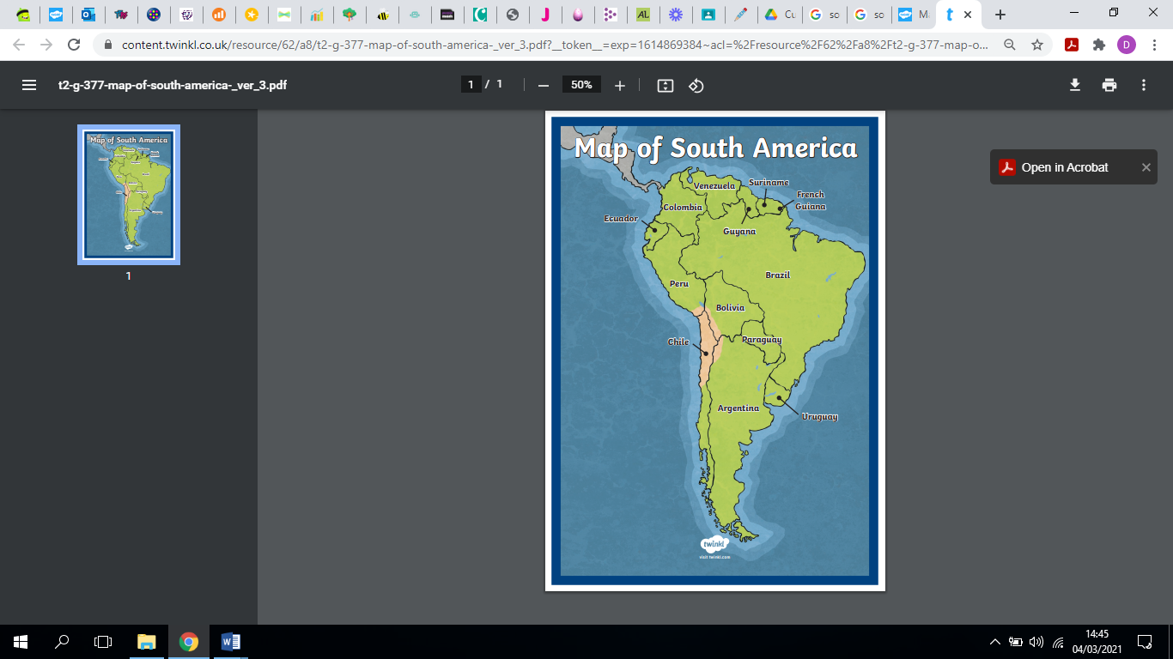

Atacama Desert, Chile

**South America**

* There are 12 countries in South America
* There is more than 385 million people living on the continent.
* The largest country is Brazil. The country covers more than half the continent's landmass.

Machu Picchu, Peru

**Key Vocabulary**

Indigenous

Landlocked

Hudroelectric

Equinox

Alpaca

Mayan

Deforestation

Rainforest

Rio de Janeiro, Brazil

The Amazon

What is life like in South America?

A map of South America