Year 2 Timetable 2024/25
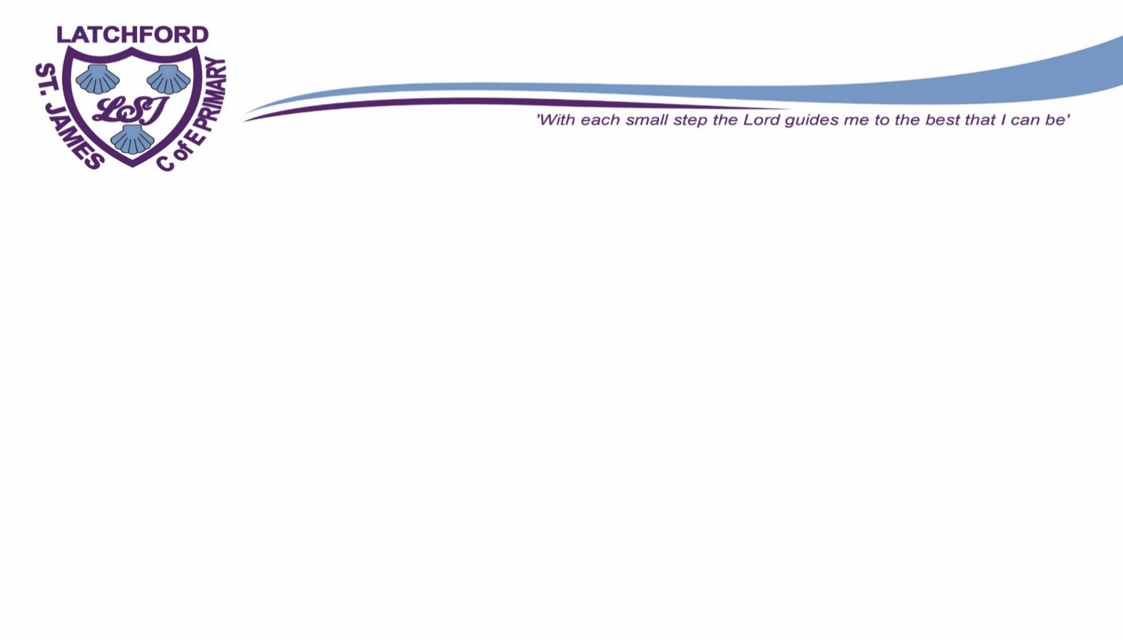  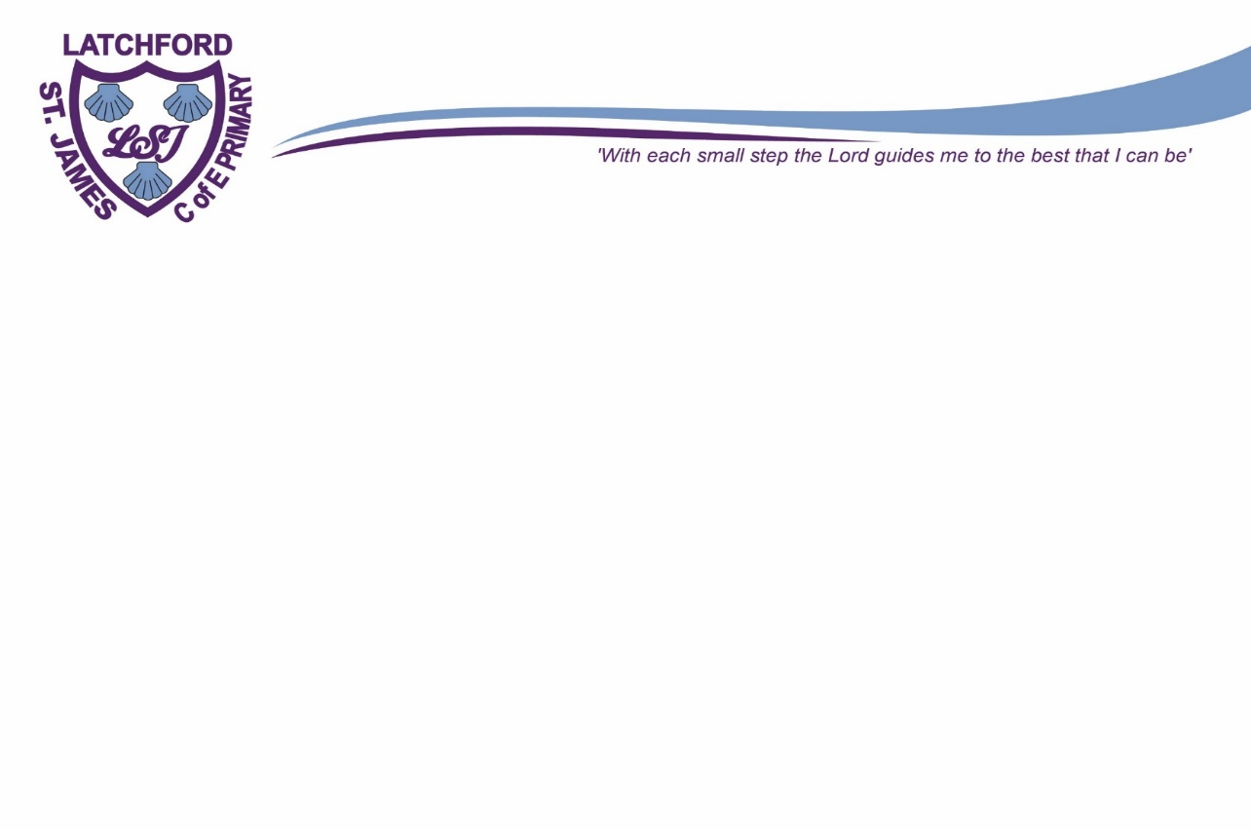  Year __1__ Timetable | Monday | Tuesday | Wednesday | Thursday | 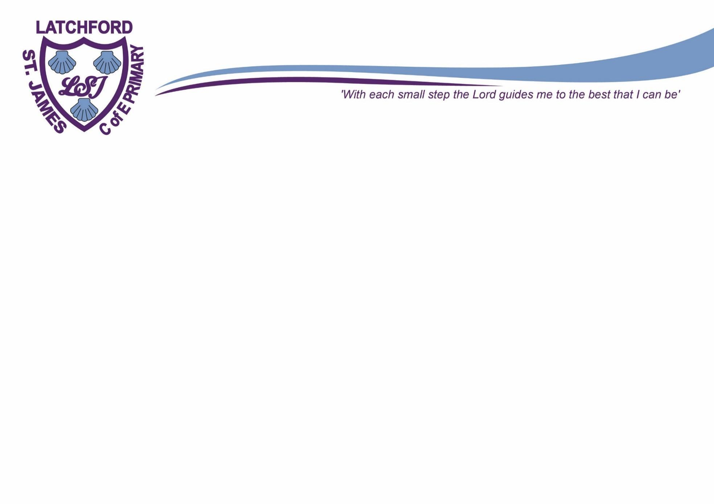  Friday
8:50-9:00am | Arithmetic | Arithmetic | Arithmetic | Arithmetic | Arithmetic
9:00-9:15 am | Collective Worship | Collective Worship | Collective Worship | Collective Worship | Celebration Worship
9:15-9:45 am | Spag /Handwriting | Spag /Handwriting | Spag /Handwriting | Spag /Handwriting | Spag /Handwriting
9:45 – 10.30am | Arithmetic / Maths | Arithmetic / Maths | Arithmetic / Maths | Arithmetic / Maths | Arithmetic / Maths
10.30 – 10.45am | Break time | Break time | Break time | Break time | Break time
10:45-12:00 am | English Writing | English Writing | English Writing | English Writing | English Writing
12:00-12:15pm | Pathways to spell | Pathways to spell | Pathways to spell | Pathways to spell | Pathways to spell
12.15 – 1:00 am | Lunch Time | Lunch Time | Lunch Time | Lunch Time | Lunch Time
1:00 – 1.15pm | Guided reading | Guided reading | Guided reading | Homework | Guided reading
1.15 – 1.40pm
1.45 -2:00pm |  | PE |  | RE | PE
2:00-2:15pm | Science
2:15-2:30pm |  | Jigsaw | History/ Geography | Art/DT
2:30-2:45pm |  |  |  |  | Music/ Computing
2:45pm – 3:00pm |  | Book change
3:00-3:15pm  3:20pm | Story/ Newsround  Home time | Story / Newsround  Home time | Newsround  Home time | Story / Newsround  Home time | Newsround  Home time

Year 2 | Autumn 1 | Autumn 2 | Spring 1 | Spring 2 | Summer 1 | Summer 2
English | Troll Swap | The owl who was afraid of the dark | Dragon Machine | Major Glad, Major Dizzy | The last wolf | Grandad’s secret giant
Science | Materials | Animals including humans | Animals including humans | BSW | Living things and their habitats | Plants
RE | The Bible | Christmas | Jesus | Easter | Ascension and Pentecost | Multi Faith week
History |  |  | How do we learn to fly?  (Kapow) | How was school different in the past?  (Kapow) |  | What is a Monarch?  (Kapow)
Geography | What is it like to live by the coast?  (Kapow) | Why is our world wonderful (kapow) |  |  | Would you prefer to live in a hot or cold place? (Kapow)
Art | Life in colour (Kapow) |  |  | Map it out  (Kapow) | Clay Houses  (Kapow)
DT |  | Balanced diet (Kapow) | Mechanisms - making a moving dragon  (Kapow) |  |  | Pouches (suffragette flag)  (Kapow)
Jigsaw | Being me | Celebrate differences | Dreams & Goals | Healthy me | Relationships | Changing me
Computing |  |  |  | Online Safety  (Kapow) | What is a computer?(Kapow) | Programming (Kapow)
Music | Instruments musical storytelling (Kapow) | Christmas / Musical me (Kapow) | Myths and Legends (Kapow)

