Autumn Term, Year 3, PE Knowledge Organiser
Fundamentals Y3/ 4
Subject specific  Vocabulary |  | Images/Diagrams/Maps | Important Knowledge
agility | The ability to change direction quickly. | 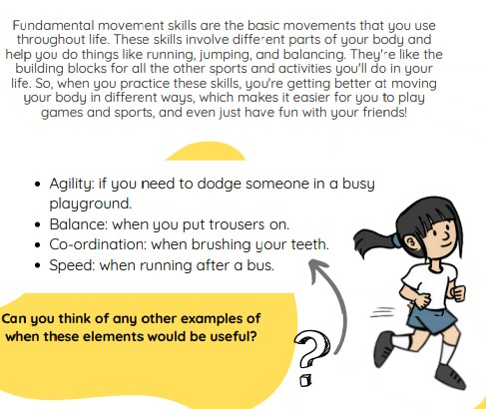 | Running  Leaning forwards helps to increase speed. Leaning backwards help you to slow down.  Balancing  Balance helps us with everyday tasks.  Jumping & hopping  If you jump and land quickly, you will travel further.  Skipping  Turn the rope from your wrists with wide hands to create a gap to step through.
balance | The ability to maintain stability when stationary (static balance) or when moving (dynamic balance)
co-ordination | Moving two or more body parts at the same time
control | Being able to perform a skill with good technique
rhythm | A strong, regular repeated pattern of movement
take off | How you leave the ground
take off | How you leave the ground | Writing/Provision/  Enrichment opportunities
technique | The action used correctly | Writing/Provision/  Enrichment opportunities
technique | The action used correctly | Children will have access to the following equipment at playtimes and lunchtimes in order to apply the skills they have learned in their Pe lessons.  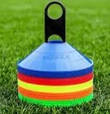      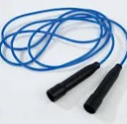  
Autumn Term, Year 3, PE Knowledge Organiser
Rugby
Subject specific  Vocabulary |  | Images/Diagrams/Maps | Important Knowledge
Attack | The offensive action of trying to score goals or points | 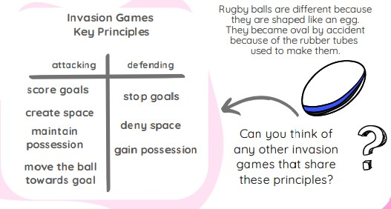 | Sending and receiving  Swing your hands to your target when throwing to help to send the ball accurately  Space  Spread out as a team to help you to move the defenders away from each other  Attacking and defending  As an attacker you need to maintain possession and score goals. As a defender you need to stop the opposition and gain possession.
Defend | Try to limit the opposition scoring by marking a space or player to gain possession
Dodge | Change direction quickly, often used to lose a defender or avoid being caught
Opposition | The other team
Pitch | The space used for a tag rugby game
Receiver | The person catching the ball
Receiver | The person catching the ball | Writing/Provision/  Enrichment opportunities
Technique | How you apply a skill | Writing/Provision/  Enrichment opportunities
Technique | How you apply a skill | Children will have access to the following equipment at playtimes and lunchtimes in order to apply the skills they have learned in their Pe lessons.
tournament | A competition of more than two teams

