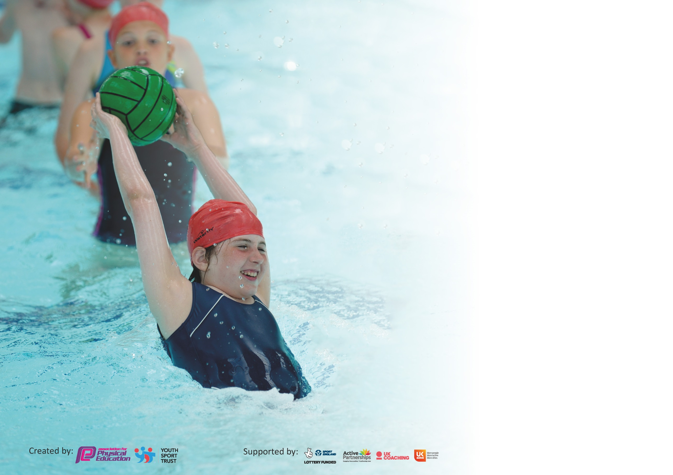

It is important that your grant is used effectively and based on school need. The Education Inspection Framework (Ofsted 2019 p64) makes clear there will be a focus on ‘whether leaders and those responsible for governors all understand their respective roles and perform these in a way that enhances the effectiveness of the school’.

Under the Quality of Education criteria (p41) inspectors consider the extent to which schools can articulate their curriculum (INTENT), construct their curriculum (IMPLEMENTATION) and demonstrate the outcomes which result (IMPACT).

To assist schools with common transferable language this template has been developed to utilise the same three headings which should make your plans easily transferable between working documents.

Schools must use the funding to make additional and sustainable improvements to the quality of Physical Education, School Sport and Physical Activity (PESSPA) they offer. This means that you should
use the Primary PE and Sport Premium to:

- Develop or add to the PESSPA activities that your school already offer
- Build capacity and capability within the school to ensure that improvements made now will benefit pupils joining the school in future years

Please visit gov.uk for the revised DfE guidance including the 5 key indicators across which schools should demonstrate an improvement. This document will help you to review your provision and to report your spend. DfE encourages schools to use this template as an effective way of meeting the reporting requirements of the Primary PE and Sport Premium.

We recommend you start by reflecting on the impact of current provision and reviewing the previous spend.

Schools are required to publish details of how they spend this funding as well as on the impact it has on pupils’ PE and sport participation and attainment by the end of the summer term or by 31st July 2020 at the latest.

Support for review and reflection - considering the 5 key indicators from DfE, what development needs are a priority for your setting and your pupils now and why? Use the space below to reflect on previous spend and key achievements and areas for development.
Key achievements to date until July 2020: | Areas for further improvement and baseline evidence of need:
- School games Silver award  - Purchase of Real Legacy scheme of work  - External provider for PE who worked successfully with Play Leaders  - Inter-school competitions and sporting events  - Active learning included in provision mapping | - New subject lead arranged during COVID  - Staff inexperienced with the planning/delivery/assessment of P.E.  - Increased participation in activity based sessions e.g. daily mile  - Monitor/track/increase pupils’ involvement in physical activity.  - Increase % of pupils meeting NC requirements at the end of KS2.

Meeting national curriculum requirements for swimming and water safety.
What percentage of your current Year 6 cohort swim competently, confidently and proficiently over a distance of at least 25 metres?
N.B. Even though your pupils may swim in another year please report on their attainment on leaving
primary school at the end of the summer term 2020.
What percentage of your current Year 6 cohort use a range of strokes effectively [for example, front crawl, backstroke and breaststroke]?
What percentage of your current Year 6 cohort perform safe self-rescue in different water-based situations?
Schools can choose to use the Primary PE and Sport Premium to provide additional provision for swimming but this must be for activity over and above the national curriculum requirements. Have you used it in this way?

Action Plan and Budget Tracking
Capture your intended annual spend against the 5 key indicators. Clarify the success criteria and evidence of impact that you intend to measure to evaluate for pupils today and for the future.

Academic Year: 2020/21 | Total fund allocated: £17,576 | Date Updated:
Key indicator 1: The engagement of all pupils in regular physical activity – Chief Medical Officer guidelines recommend that primary school pupils undertake at least 30 minutes of physical activity a day in school |  |  |  | Percentage of total allocation:
 |  |  |  | %
Intent | Implementation |  | Impact
Your school focus should be clear what you want the pupils to know and be able to do and about  what they need to learn and to  consolidate through practice: | Make sure your actions to achieve are linked to your intentions: | Funding allocated: | Evidence of impact: what do pupils now know and what can they now do? What has changed?: | Sustainability and suggested next steps:
Target swimmers who did not meet the assessment criteria to meet national requirements for swimming and water safety.  Increase the engagement of all pupils in at least 30 minutes physical activity per day.  Arrange School Sports Organising Crew (SSOC) training through WASSP.  Monitor activity levels of pupils and target the inactive to attend clubs (COVID permitting) and engage in Playleader activities.  Ensure there are a range of activities for pupils at lunchtimes. | Analyse swimming data and identify target pupils. Organise top-up sessions.  Complete activity heat map tool for each class. Implement daily mile and introduce Go Noodle in lessons.  Contact Penny Moorfield/Dave Ansell to arrange SSOC training to take place in Autumn term (COVID permitting)  Send out class surveys regarding pupil engagement in after school and out of school clubs. Analyse data and invite inactive pupils to attend clubs (COVID permitting).  Playleaders to give out equipment and suggested games to staff to implement at lunchtime. Audit and order resources if necessary. Update midday assistants’ training.
Key indicator 2: The profile of PESSPA being raised across the school as a tool for whole school improvement |  |  |  | Percentage of total allocation:
 |  |  |  | %
Intent | Implementation |  | Impact
Your school focus should be clear what you want the pupils to know and be able to do and about  what they need to learn and to  consolidate through practice: | Make sure your actions to achieve are linked to your intentions: | Funding allocated: | Evidence of impact: what do pupils now know and what can they now do? What has changed?: | Sustainability and suggested next steps:
Target swimmers who did not meet the assessment criteria to meet national requirements for swimming and water safety.  PE, school sport and healthy active lifestyles to be actively promoted on our website and social media.  All children participating in every PE lesson unless they are unwell.  Celebration assemblies to promote effort and success in PE, school sport and out-of-school sport.  Set up School Sports Organising Committee with Y5 pupils to raise the profile of sports at breaks and lunchtimes.  Playleaders and SSOC to raise profile of sport at lunch and break times.  Continue with inter-house sports day where children across the school are able to compete with one another in a range of activities to earn house points.  Raise the profile of sport by sharing activities and competitions on the school website and Facebook page. | Analyse swimming data and identify target pupils. Organise top-up sessions.  Staff to upload photos/write commentary of events on social media.  Purchase spare kits for when children don’t have theirs.  Contact Dave Ansell to arrange for pupil SSOC training. Appoint adult to oversee.  Provide Playleaders and SSOC with caps to be easily identified.  Organise inter-house sports day for summer term (COVID permitting).  Staff to upload photos and narrative to website and Facebook page.

Key indicator 3: Increased confidence, knowledge and skills of all staff in teaching PE and sport |  |  |  | Percentage of total allocation:
 |  |  |  | %
Intent | Implementation |  | Impact
Your school focus should be clear | Make sure your actions to | Funding | Evidence of impact: what do | Sustainability and suggested
what you want the pupils to know | achieve are linked to your | allocated: | pupils now know and what | next steps:
and be able to do and about | intentions: |  | can they now do? What has
what they need to learn and to |  |  | changed?:
consolidate through practice:
All staff to be fully trained and supported with delivery of PE within school.  Real Legacy scheme of work to be implemented across school.  PE lead to attend network meetings and disseminate information.  New subject lead to have thorough understanding of the role, PE funding and how to support staff to ensure teaching of PE is at least good in all classes.  Purchase the LiveWire membership as part of ongoing development for staff. | Real PE training organised in A2 for all staff. Arrange demonstration/team-teaching lessons with BC and VR.  Monitor impact. Purchase the LiveWire membership as part of ongoing development for staff  Real Gym training to take place in Spring term. Monitor impact.  Attend PE meetings and feedback to staff. Work with more experienced PE leads for support with the role and allocation of PE funding.
Key indicator 4: Broader experience of a range of sports and activities offered to all pupils |  |  |  | Percentage of total allocation:
 |  |  |  | %
Intent | Implementation |  | Impact
Your school focus should be clear | Make sure your actions to | Funding | Evidence of impact: what do | Sustainability and suggested
what you want the pupils to know | achieve are linked to your | allocated: | pupils now know and what | next steps:
and be able to do and about | intentions: |  | can they now do? What has
what they need to learn and to |  |  | changed?:
consolidate through practice:
Engage the least active children in sport.  Ensure there is a broader range of sports on offer, both curricular and extra-curricular (COVID permitting).  Develop close links with local clubs and professional coaches to widen experiences and opportunities. | Audit pupil participation in clubs to identify the least active. Discuss with the least active what physical activities would engage them and plan these opportunities.  Livewire and WaSSP membership: access to training, support, competitions and experiences throughout the year (COVID permitting).  Source qualified coaches to deliver specialist clubs.

Key indicator 5: Increased participation in competitive sport |  |  |  | Percentage of total allocation:
 |  |  |  | %
Intent | Implementation |  | Impact
Your school focus should be clear | Make sure your actions to | Funding | Evidence of impact: what do | Sustainability and suggested
what you want the pupils to know | achieve are linked to your | allocated: | pupils now know and what | next steps:
and be able to do and about | intentions: |  | can they now do? What has
what they need to learn and to |  |  | changed?:
consolidate through practice:
Provide children with more competitive opportunities in lessons.  Provide children with more inter/intra competition opportunities. (COVID permitting)  Raise participation of inactive pupils in competitive sport. | Livewire and WaSSP membership. Enter Virtual Games competitions. Hold inter-house sports competition and Sports Day (COVID permitting). Use the real PE programme for lessons as competition is built into these.  Organise sports day and inter-house sports day. Enter Virtual School Games. Partake in sporting competitions in the authority and provide transport to and from events.  Identify inactive pupils and invite them to compete.

Signed off by
Head Teacher:
Date:
Subject Leader:
Date:
Governor:
Date:

