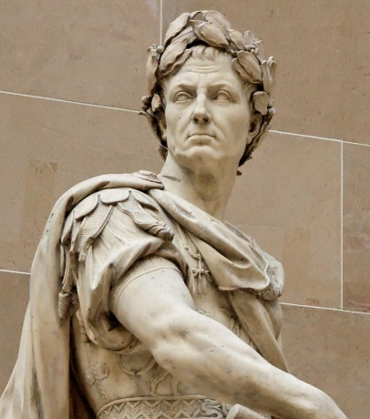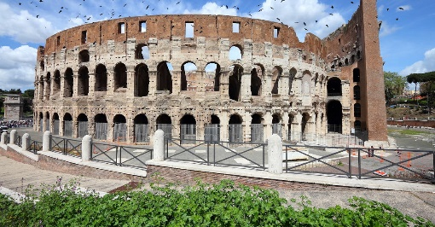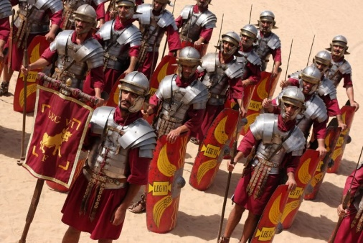[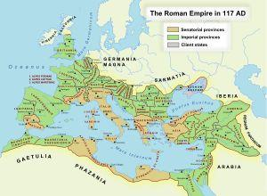](https://www.ducksters.com/history/roman_empire_map_large.png)

**5 Roman inventions**

Concrete Central Heating

Newspapers The calendar

Books Air conditioning

**Key Facts**

The city of Rome is the capital of Italy today. It sits on the same site as the city of ancient Rome.

If you were to visit Rome you could see many of the original ancient buildings such as the Colosseum and the Roman Forum.

The fall of Western Rome is considered the start of the "Dark Ages" in Europe.

The native language of the Romans was Latin, but they often spoke Greek as well.

A sculpture of Julius Caesar

The Colosseum

A Roman Legion

**Key Vocabulary**

Empire

Toga

Aqueduct

Coliseum

Centurion

Emperor

Amphitheatre

Senate

Gladiator

Republic

Mosaic

Arch

Chariot

Tunic

Pantheon

Testudo

Legionary

What did the Romans ever do for us?

**Roman Empire Timeline**

**753 BC** - The city of Rome is founded. Legend has it that the twin sons of Mars, the god of war, named Romulus and Remus founded the city.   
  
**509 BC** - Rome becomes a republic. The last king is overthrown and Rome is now ruled by elected officials called senators.  
  
**202 BC** – Rome conquers territories outside of Italy and it’s power grows  
  
**130 BC** – Rome conquers Greece and Spain, expanding the Roman Empire..

**45 BC** - Julius Caesar becomes the first dictator of Rome.   
  
**44 BC**- Julius Caesar is assassinated on the Ides of March by Marcus Brutus.   
  
**27 BC** - The Roman Empire begins as Caesar Augustus becomes the first Roman Emperor.

**1 AD** – Jesus is born.

**43 AD** – The Romans conquer Britain.

**61 AD** – Boudicca rebels against the Romans  
  
**64 AD** - Much of Rome burns. Legend has it that Emperor Nero watched the city burn while playing a lyre.

**70s AD** – Romans founded Chester, it was originally called Deva Victrix  
  
**80 AD** - The Colosseum is built. One of the great examples of Roman engineering is finished. It can seat 50,000 spectators.

**121 AD**– Hadrian’s Wall is built. To keep out the barbarians from Scotland a long wall is built across northern England.  
  
**200 AD** – Rome is attacked by Barbarians

**235-285 AD** – 20 Roman emperors are assassinated in the space of 50 years  
  
**410 AD** - The roman rule of Britian comes to an end and the city of Rome is attacked by The Visigoths and falls. The roman Empire is becoming weak.  
  
**476 AD**- The end of the Roman Empire and the fall of Ancient Rome.