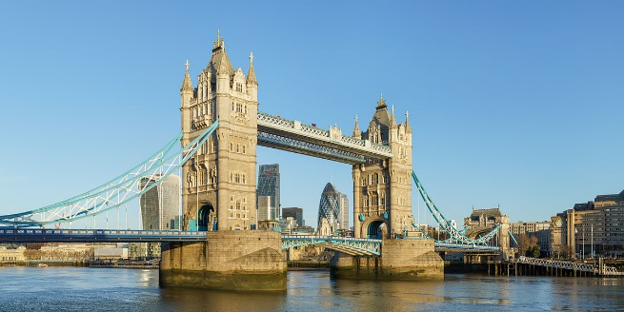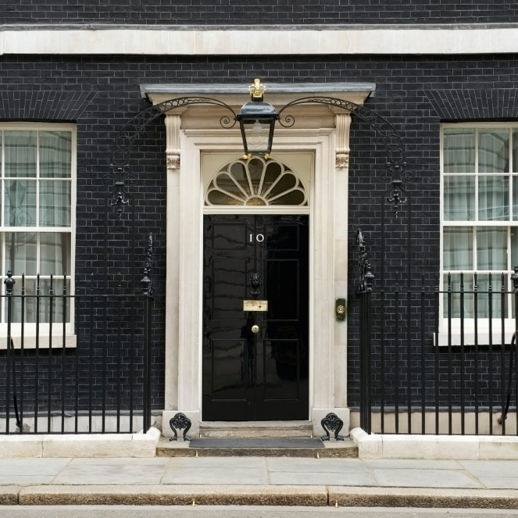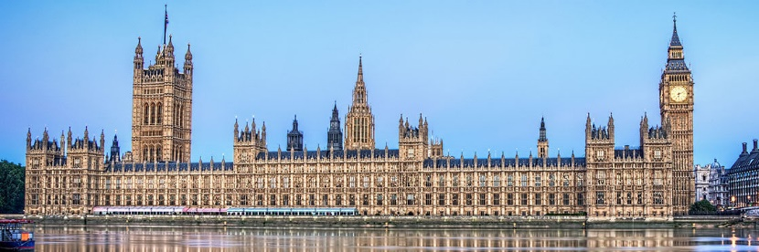

A Timeline of key events in London’s History

**884 AD** - London becomes the capital of Britain under Alfred the Great.

**1042 AD** - Edward the Confessor moves his court from the city to Westminster and rebuilds the abbey.

**1176 AD** - A new London Bridge is built of stone.

**1189 AD** - City’s first mayor is elected.

**1240 AD** - First parliament sits in Westminster.

**1300 AD** - St Paul’s Cathedral, now rebuilt in stone after a fire in 1087, is consecrated.

**1485 AD** - The Tudor Age begins. Of Welsh descent, the Tudors preside over the English Renaissance, under Queen Elizabeth I (reigned 1558–1603).

**1534 AD** - Henry VIII declares himself head of the Church of England and dissolves the monasteries.

**1588 AD** - William Shakespeare (1568–1616) be­gins his dramatic career in London.

**1605 AD** - Guy Fawkes tries to blow up Parliament.

**1664-6 AD** - The Great Plague kills one-fifth of the population.

**1666 AD** - The Great Fire destroys 80 percent of London’s buildings.

**1675 AD** - Sir Christopher Wren (1632–1723) begins work on St Paul’s Cathedral.

**1735 AD** - George II makes 10 Downing Street available to Sir Robert Walpole, Britain’s first prime minister.

**1829 AD** - Prime Minister Robert Peel establishes a police force (nicknamed “peelers” and later “bobbies”).

**1834 AD** - Rebuilding of the current Houses of Parliament, after the old palace of Westminster is destroyed by fire.

**1837 AD** - Queen Victoria comes to the throne at 18.

**1859 AD** - A 13.5-tonne bell, nicknamed Big Ben, is hung in the clock tower of the Houses of Parliament.

**1894 AD** - Tower Bridge is built.

**1903 AD** - Westminster Cathedral is built.

**1914 AD** - World War I begins.

**1922 AD** - British Broadcasting Company transmits its first programmes.

**1923 AD** - The first Football Association cup final is held at Wembley Stadium.

**1939-45 AD** - World War II. Children are evacuated, and London is heavily bombed.

**1994 AD** - The first trains run through the Channel Tunnel to Paris and Brussels.

**2007 AD** - The new Wembley Stadium opens. Eurostar terminal opens at St Pancras.

**2012 AD** - London Olympics are held. Queen Elizabeth II’s ­Diamond Jubilee is ­celebrated.

**London Vocabulary**

city of London

England

greater London

city of Westminster

river Thames

London underground

Trafalgar square

tower of London

Westminster abbey

Greenwich

st Paul’s cathedral

central London

borough

Tate modern

London eye

national gallery

canary wharf

Wembley stadium

10 Downing Street

The Palace of Westminster

Tower Bridge

Why is London the Capital of England?