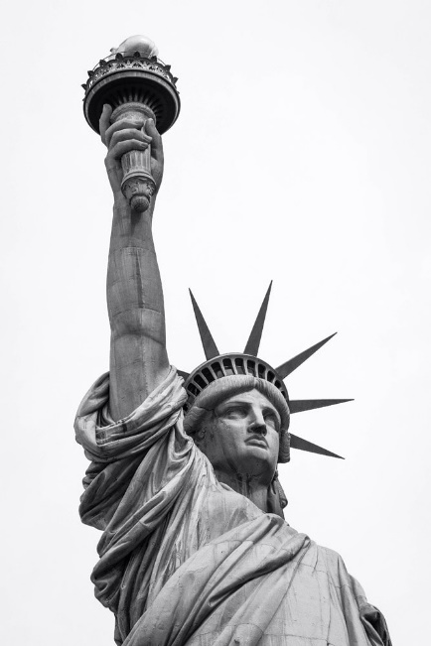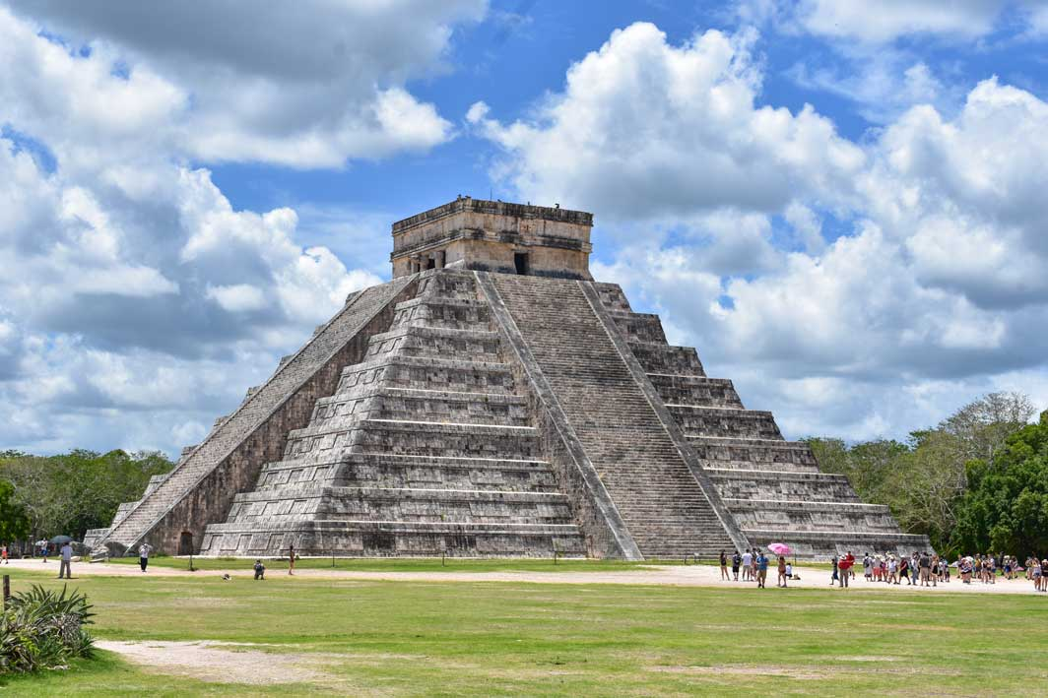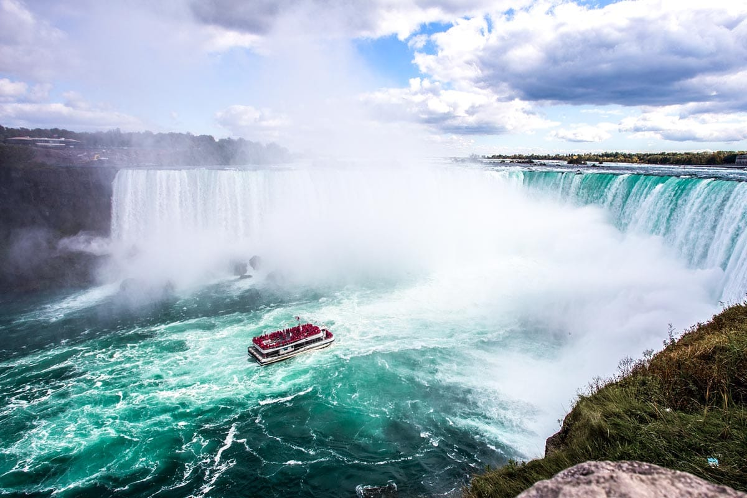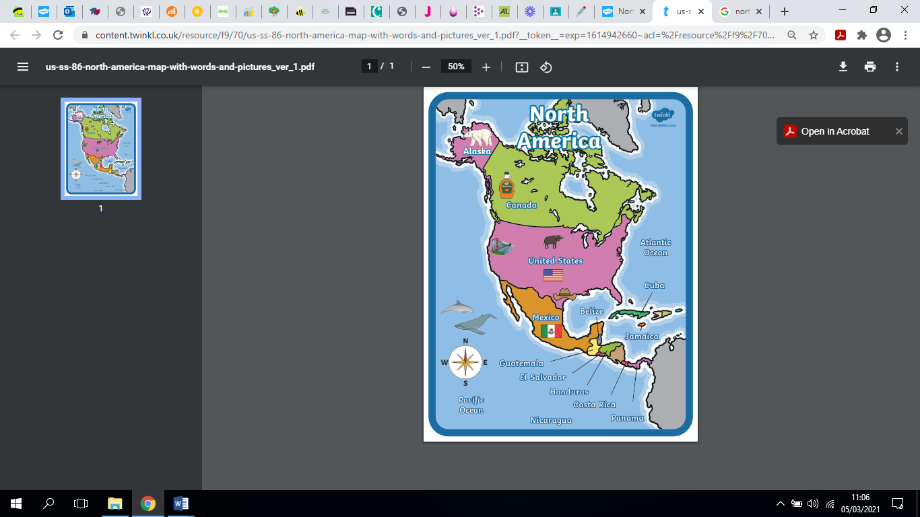

**Key Vocabulary**

Statue of Liberty

Chichen Itza, Mexico

**North America**

* There are 23 countries in North America
* There are more than 590 million people living on the continent.
* The largest country is Canada; the country covers almost half the North American continent's land area.

Niagara Falls

A map of North America

What is life like in North America?