Autumn Term, Year 1, PE Knowledge Organiser
Fundamentals 1
Subject specific  Vocabulary |  | Images/Diagrams/Maps | Important Knowledge
bend | To move a part of your body so it's not straight anymore. | =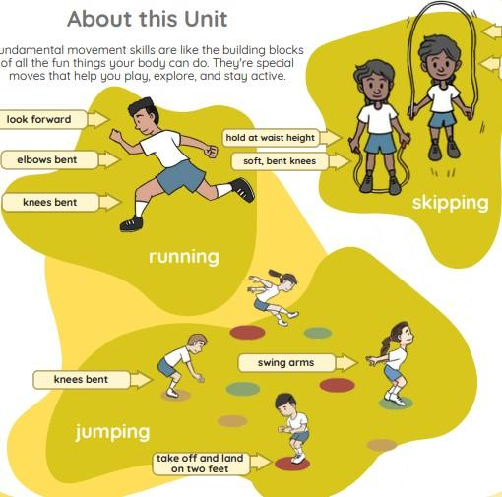 | Running  Bending your knees will help you to change direction. If you swing your arms it will help you to run faster.  Balancing  Look ahead will help you to balance. Landing on your feet helps you to balance.  Jumping  Landing on the balls of your feet helps you to land with control.  Hopping  Hop with a soft bent knee.  Skipping  Use the opposite arm to leg when you skip. Jumping on the balls of your feet helps you to keep a rhythm.
direction | The way you move or face during an activity or game.
dodge | To move quickly to the side or away so you don’t get tagged or hit by something.
fast | Moving quickly from one place to another.
hop | To jump off the ground on one foot and land on the same foot.
jog | To run at a slow and steady pace.
jog | To run at a slow and steady pace. | Writing/Provision/  Enrichment opportunities
jump | To push off the ground with your feet and go up into the air. | Writing/Provision/  Enrichment opportunities
jump |  | Children will have access to the following equipment at playtimes and lunchtimes in order to apply the skills they have learned in their Pe lessons.  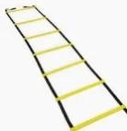  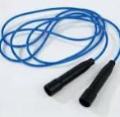      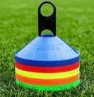
land | To come back down and touch the ground with your feet after you jump.
swing | To move back and forth, like when you're on a swing at the playground.
skip | To hop on one foot and then the other in a fun, bouncy way.

Autumn Term, Year 1, PE Knowledge Organiser
Team Work 1
Subject specific  Vocabulary |  | Images/Diagrams/Maps | Important Knowledge
challenge | Trying something that’s a little hard or new for you. | 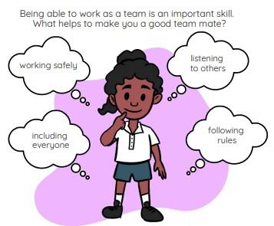 | Problem Solving  Working well with others will help you to solve challenges.  Navigational skills  Deciding which way to go before starting will help you.  Communication  Using short instructions when telling a partner what to do will help them understand.  Reflection  We can always be better, we just need to look for how.
co-operate | Working together with your friends to do something as a team.
instruction | When your teacher or coach tells you what to do or how to do something.
lead | To be the person who shows others what to do or guides the group.
listen | To use your ears to pay close attention when someone is talking, so you can understand what to do and stay safe.
plan | To think ahead and decide what you want to do before you start.
plan |  | Writing/Provision/  Enrichment opportunities
share | To let others use or have something with you, like a ball or a turn. | Writing/Provision/  Enrichment opportunities
share |  | Children will be encouraged to work together and reminded of the principals taught in PE across all subjects. Children will also be given the opportunity to practise these skills in different situations and different subject lessons.
talk | To use your voice to say words so others can hear you.

