Autumn Term, Year 4, PE Knowledge Organiser
Swimming
Subject specific  Vocabulary |  | Images/Diagrams/Maps | Important Knowledge
Backstroke | A swimming style performed on the back | 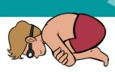 | Strokes  Keeping your legs together for crawl helps you to stay straight in the water  Breathing  Breathing out with a slow consistent breath enables you to swim with good technique  Water Safety  If you fall in the water float
Breaststroke | A swimming style performed on the front
Front crawl | A stroke used in swimming
Glide | Move across the water with a smooth continuous movement
H.E.L.P position | Heat Escape Lessening Posture a position for floating in cold water when wearing a life jacket and awaiting rescue
Handstand | An inverted balance in which weight is held on hands
Handstand | An inverted balance in which weight is held on hands | Writing/Provision/  Enrichment opportunities
Rotation | The circular movement of an object around central point | Writing/Provision/  Enrichment opportunities
Rotation | The circular movement of an object around central point | Water Safety work during Sports Week
Sculling | Quick movements of the hands to keep the head above the water | Water Safety work during Sports Week
Sidestroke | A stroke where the swimmer lies on their side, helpful as a lifesaving stroke as it uses less energy | Water Safety work during Sports Week
Submerge | To be underwater | Water Safety work during Sports Week

Autumn Term, Year 4, PE Knowledge Organiser
Rugby
Subject specific  Vocabulary |  | Images/Diagrams/Maps | Important Knowledge
Accelerate | Speed up | 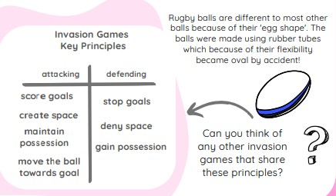 | Sending and receiving  Cushioning the ball will help you to control it when catching it  Space  Moving into space will help your team keep possession and score goals  Attacking and defending  As an attacker runs to the try line if there is a clear path. Pass when a teammate is free and in a good space. Aas a defender tracks a player to stop them from being an option. Try to tag the ball carrier.
Forward pass | When the ball is passed in the direction of a team’s try line
invasion | A game of two teams who invade each other’s space to score goals
Offside | When a tag is made, all defending players must get into an onside position. Onside is in front of the ball carrier, offside is behind the ball carrier
Onside | When the defender is in front of the ball carrier
Possession | To have
Possession | To have | Writing/Provision/  Enrichment opportunities
Track | To move your body to get in line with a ball that is coming towards you | Writing/Provision/  Enrichment opportunities
Track |  | Children will have access to the following equipment at playtimes and lunchtimes in order to apply the skills they have learned in their Pe lessons.  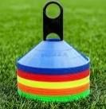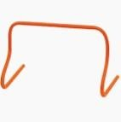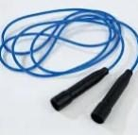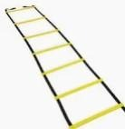
Try | The name of a point scored by placing the ball over the try line

