Autumn Term, Year 2, PE Knowledge Organiser
Fundamentals 2
Subject specific  Vocabulary |  | Images/Diagrams/Maps | Important Knowledge
balance | Staying steady and not falling over when you stand, walk, or move. | 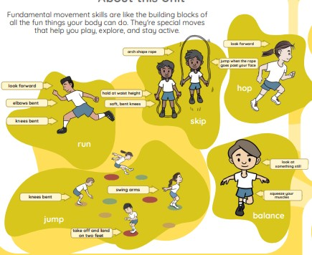 | Running  Putting weight into the front of your feet helps you to stop in a balanced position. Running on the balls of your feet, taking big steps and having elbows bent will help you to run faster.  Balancing  Squeezing your muscles helps you to balance.  Jumping  Swinging your arms forwards will help you to jump further.  Hopping  If you look ahead it will stop you from falling over when you land.  Skipping  Swing opposite arm to leg to help you to balance when skipping without a rope.
hurdle | A small fence or bar you jump over when running.
dodge | To move quickly to the side or away so you don’t get tagged or hit by something.
fast | Moving quickly from one place to another.
hop | To jump off the ground on one foot and land on the same foot.
speed | How fast you can move your body, like running, jumping, or throwing.
speed |  | Writing/Provision/  Enrichment opportunities
jump | To push off the ground with your feet and go up into the air. | Writing/Provision/  Enrichment opportunities
jump |  | Children will have access to the following equipment at playtimes and lunchtimes in order to apply the skills they have learned in their Pe lessons.  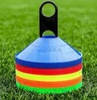      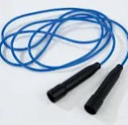  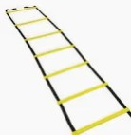
weight | How much your body or something else presses down on the ground.
swing | To move back and forth, like when you're on a swing at the playground.
Take off | To push yourself up and leave the ground when you jump, run, or start moving fast.
Autumn Term, Year 2, PE Knowledge Organiser
Team Work 2
Subject specific  Vocabulary |  | Images/Diagrams/Maps | Important Knowledge
communicate | To share your ideas or feelings with others by talking, listening, or using gestures. | 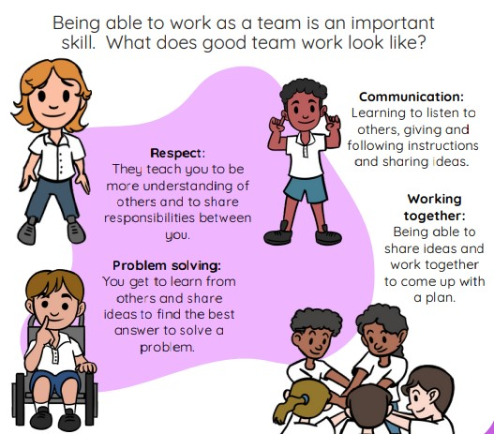 | Problem Solving  Listening to each other’s ideas might give you an idea you hadn’t thought of.  Navigational skills  A map tells us where we are.  Communication  Using encouraging words when speaking to a partner or grp will help them to trust you.  Reflection  Reflect on what you have done well and what you could improve will help you if you play again.
include | To make sure everyone is part of the game or activity, so no one feels left out.
instruction | When your teacher or coach tells you what to do or how to do something.
map | A picture or drawing that shows where things are or where to go.
solve | To figure out the answer or fix a problem, like how to win a game or get through an obstacle.
plan | To think ahead and decide what you want to do before you start.
plan |  | Writing/Provision/  Enrichment opportunities
successful | Doing your best and reaching a goal, like finishing a race or learning a new skill. | Writing/Provision/  Enrichment opportunities
successful |  | Children will be encouraged to work together and reminded of the principals taught in PE across all subjects. Children will also be given the opportunity to practise these skills in different situations and different subject lessons.  Map reading in Geography lessons.
support | Helping your friends by cheering them on, helping them if they need it, or working together as a team.

