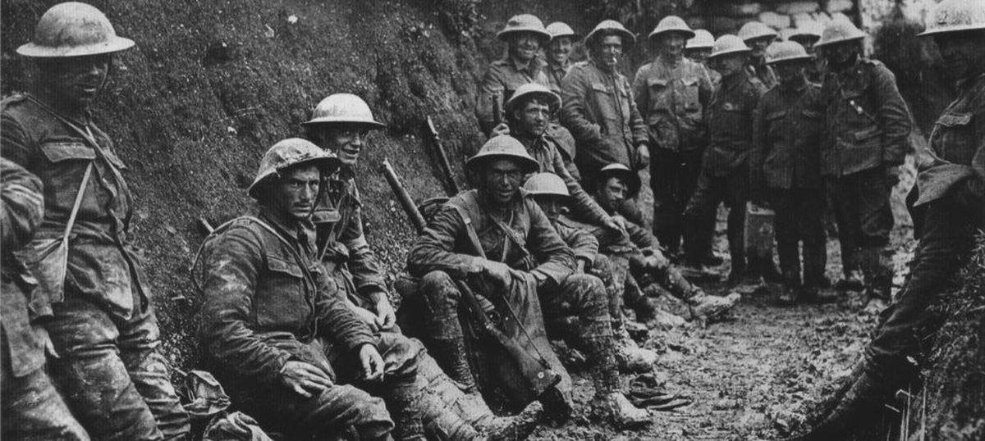

**WWI Key Vocabulary**

Allied Powers

Armistice

Artillery

Big four.

Blockade

Central Powers - The Central Powers

Conscript

Christmas Truce

Dreadnought

Fourteen Points

Front line

League of Nations

No Man's Land

Pacifist

Propaganda

Reparations

Schlieffen Plan

Treaty of Versailles.

Trench warfare

U-boat

Western front

Zimmerman Telegram.

**Wars (selected) since 1066**

* Norman Conquest (1066)
* Crusades (1095–1291; sporadically thereafter)
* Hundred Years’ War (*c.* 1337–1453)
* Wars of the Roses (1455–85)
* English Civil Wars (1642–51)
* American Revolution (1775–83)
* French Revolution (1787–99)
* French revolutionary wars (1792–1801)
* Napoleonic Wars (1803–15)
* Crimean War (1853–56)
* American Civil War (1861–65)
* War of the Pacific (1879–83)
* Boxer Rebellion (1900–01)
* World War I (1914–18)
* World War II (1939–45)
* Vietnam War (1954–7510
* Iran-Iraq War (1980–88)
* Falkland Islands War (1982)
* Persian Gulf War (1990–91)
* Afghanistan War (2001–14)
* Iraq War (2003–11)

**WWII Key Vocabulary**

Air raid

Air raid drill

Air raid shelter

Allies powers.

Allotment

Atomic bomb

Axis powers

Blackout

Blitz

British empire

Censorship

Civilians

Concentration camp

Ration coupons

D-day

Evacuee

Factories

Anne Frank

Gas mask

Adolf Hitler

Holocaust

Liberate

Navy

Nazi

Occupied

Prisoners of war

Propaganda

Rationing

Refugee

Siren

Slogan

Telegram

United nations

washboard

Wooden board with ridges, for scrubbing dirty clothes on.

**World War Two Timeline**

**1939**

**1st September** – Germany invades Poland.

**3rd September** – British Prime Minister Neville Chamberlain declares war on Germany as do Canada, France, South Africa and Australia.

**17th September** – The Soviet Union invades Poland

**1940**

**9th April** – Germany invades Denmark and Norway

**10th May** – Winston Churchill becomes Prime Minister of Britain. Germany attacks Western Europe.

**12th May** – German forces enter France

**14th May** – The Netherlands surrenders to Germany. The Home Guard is formed in Britain.

**28th May** – Belgium surrenders to Germany.

**9th June** – Norway surrenders to Germany

**10th June –** Italy declares war on Britain and France

**22nd June –** France surrenders to Germany.

**10th July** – The Battle of Britain is fought.

**7th September** – The London Blitz begins.

**27th September** – November – Japan, Italy, Slovakia, Hungary, Bulgaria and Romania side with Germany

**1941**

**22nd June** – Germany invades the Soviet Union

**7th December** – The Japanese attack the American port of Pearl Harbour, this causes America to declare war on Japan, Germany and Italy.

**1943**

Battles are fought between the Axis and Allies powers for territory across the world.

**1944**

**6th June** – British and American forces land in Normandy for the D-day landings. The Axis powers begin to be pushed back.

**1945**

**30th April** – After realising the end is near, German leader, Adolf Hitler commits suicide

**7th May** – Germany Surrenders to the Allies

**8th May** – Britain celebrates VE day

**6th August** – America drops the first Atomic Bomb on Hiroshima in Japan decimating the city.

**2nd September** – Japan surrender officially ending the war,

**World War One Timeline**

**1914**

**28th June** – Austrian Archduke Franz Ferdinand is assassinated by a Serbian terrorist.

**28th July** – Austria-Hungary declares war on Serbia, Russia mobilizes their army

**1st August** – German declares war on Russia

**3rd August** – Germany declares war on France

**4th August** – Germany invades Belgium and Britain declares war on Germany

**5th September** – The German army is stopped from invading Paris by the French and British. Both sides dig trenches to fight against each other and trench warfare begins.

**October-November**- War spreads across Europe involving Russia and the Ottoman Empire.

**24th December** – The Christmas Truce

**1915**

**7th May** – 1195 civilians are killed when a German submarine sunk the British boat the Lusitania. America Joins the war while

Battles are fought across Europe for months in an attempt to gain territory.

**1916**

**1st July** – The battle of the Somme

**1917**

**6th April** – America officially declares war on Germany.

**17th December** – Russia officially leaves the war.

**1918**

**15th July –** The second battle of the Marne begins and ends with a decisive victory for the Allies.

**11th November –** Armistice is agreed, at the 11th hour of the 11th day of the 11th month.

**1919**

**June 28th** – The treaty of Versailles is signed and the war is officially over.

War, what is it good for?