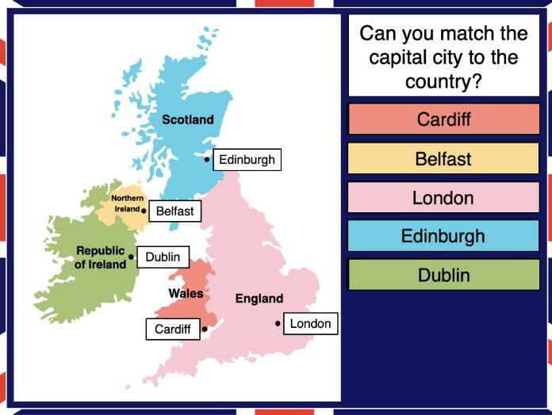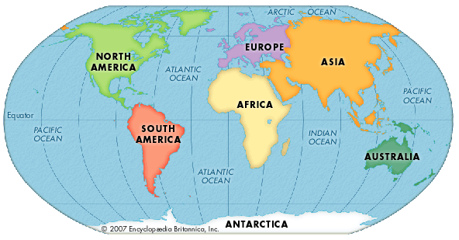

|  |  |
| --- | --- |
| **England**   * England is the most populated country in the United Kingdom. * The highest mountain in England is Scafell Pike, which stands at around 978 metres (3,209 ft) in height. | **Scotland**   * Scotland includes over 700 islands. These include groups called Orkney, Shetland and the Hebrides. * The unicorn is the national animal of Scotland |
| **Wales**   * Wales is called Cymru in Welsh. * The country of Wales is said to contain more castles per square mile than any other country in the world. | **Northern Ireland**   * Sometimes Northern Ireland is called **Ulster**, the ancient name of that part of Ireland. * The population of Northern Ireland is about 1.8 million. |

|  |  |
| --- | --- |
| **Africa**   * There are 54 countries in Africa * There are a total of more than 1.1 billion people living on the continent, which is 15% of the world's total population. * The largest country in Africa is Algeria. | **Asia**   * There are 48 countries in Asia * Two of the Asian countries also share part of their territory on the European continent; these countries are Russia and Turkey. * More than 4.4 billion people live on the continent. Asia is the most populous continent. * Russia is the largest country in Europe but China has the largest population. |
| **Australia/Oceania**   * Oceania is in a continental group consisting of numerous countries and includes Pacific islands and Australia. * Often Australia is named as continent, but this means that the many islands and countries except Australia would then be not included. * Oceania in fact is mostly ocean and spans a vast area. * Oceania includes 14 countries | **Europe**   * There are 50 countries in Europe, of these 50 countries only 44 have their capital city on the European continent! * There are a total of more than 742 million people living on the continent. * The largest country in Europe is the European part of Russia. * The three largest countries are: Russia, the Ukraine and France. |
| **North America**   * There are 23 countries in North America * There are more than 590 million people living on the continent. * The largest country is Canada; the country covers almost half the North American continent's land area. | **South America**   * There are 12 countries in South America * There is more than 385 million people living on the continent. * The largest country is Brazil. The country covers more than half the continent's landmass. |
| **Antarctica**   * According to size, Antarctica is the fifth largest continent of our planet. The continent is almost double the size of Australia! * Antarctica is an ice covered continent surrounded by the Southern Ocean. Almost all of the continent's land is covered by a thick layer of ice. * Antarctica is the least populated continent. There are no residents living permanently here. | |

**Key Vocabulary**

Earth

Globe

Asia

Europe

Africa

North America

South America

Australia

Antarctica

Pacific

Atlantic

Indian

Southern

Arctic

equator

desert

grassland

jungle

Where in the world are we?