Autumn Term, Year 6, PE Knowledge Organiser
Fitness
Subject specific  Vocabulary |  | Images/Diagrams/Maps | Important Knowledge
abdominals | Muscles in the stomach | 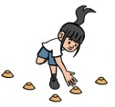  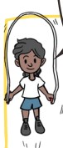 | Agility  Agility requires speed, strength, good balance and co-ordination.  Balance  Apply force to maintain control and balance.  Speed  Speed can be improved by training. Different distances require different speeds.  Strength  You can build up strength by practicing in your own time.  Co-ordination  Co-ordination also requires good balance.  Stamina  Different exercises can develop stamina which can be improved by training over time.
analyse | Examine in order to understand
calves | A muscle in the bottom back of leg
consistent | To repeat something in the same way
drive | A forceful and controlled movement to help you move forwards
engage | To activate
engage | To activate | Writing/Provision/  Enrichment opportunities
measure | To mark a distance | Writing/Provision/  Enrichment opportunities
measure | To mark a distance | Children will have access to the following equipment at playtimes and lunchtimes in order to apply the skills they have learned in their Pe lessons.  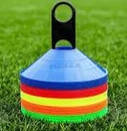  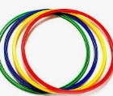    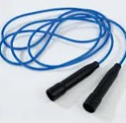  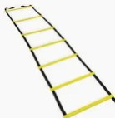
motivate | To encourage
perseverance | To continue trying
stable | To be balanced

Autumn Term, Year 6, PE Knowledge Organiser
Dance
Subject specific  Vocabulary |  | Images/Diagrams/Maps | Important Knowledge
aesthetic | How a performance or skill looks | 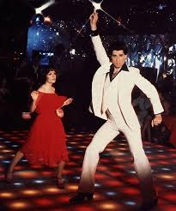  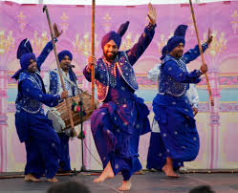 | Actions  Actions can be improved with consideration to extension, shape and recognition of intent. Remember what you are trying to tell the audience when choosing your actions.  Dynamics  Selecting a variety of dynamics in your performance can help to take the audience on a journey through your dance idea.  Space & Relationships  Combining space and relationships with a prop can help you to express your dance idea.
canon | When performers complete the same action one after another
choreograph | Create a sequence of actions or movements
collaborate | Work jointly with others
express | Make suggestions
freeze frame | When performers create an image without movement
freeze frame | When performers create an image without movement | Writing/Provision/  Enrichment opportunities
genre | A style | Writing/Provision/  Enrichment opportunities
genre | A style | Research different dance types and create a leaflet about two contrasting dance styles.
refine | To improve the quality
stimulus | Something that creates ideas
pathway | Designs traced in space

